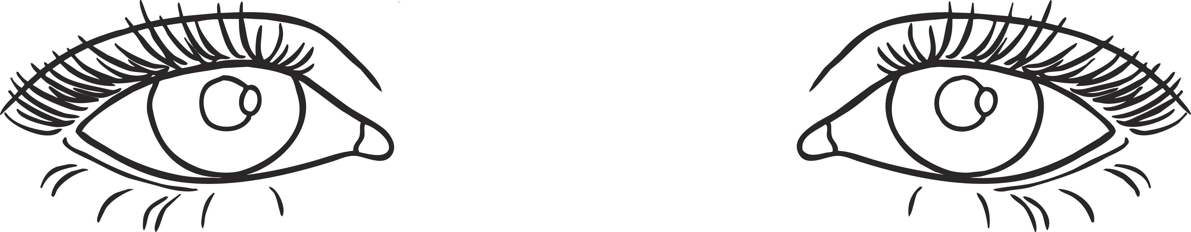
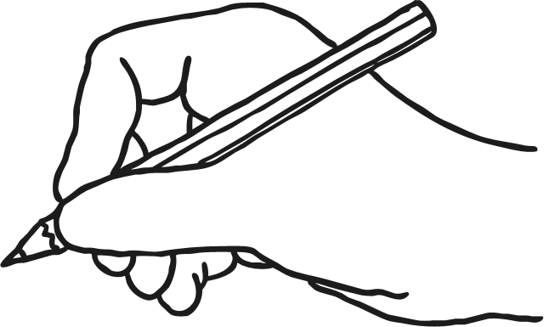
Look and Say
Look, Say
and Write
Cover
and Write
fetch
catch
stitch
witch
Look and Say
Look, Say
and Write
Cover
and Write
child
kind
pint
find

Look and Say
Look, Say
and Write
Cover
and Write
some
where
were
there

