My Year in
Class 1

Name........................................................................
Age............................. Year...................
My Self Portrait

My favourite place in school:
____________________
____________________
____________________

My favourite things:
My favourite subject:

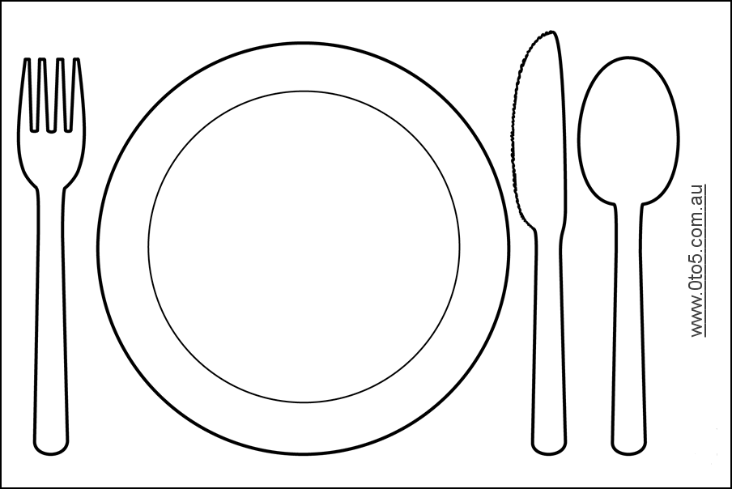
My favourite school lunch:
________________________
________________________

My favourite book:
_____________________
_____________________
_____________________

What I like about
being in Class 1
- __________________________
- __________________________
- __________________________
- __________________________

My Favourite Lessons

In Class 1 my favourite lessons were:
____________________________________________________
____________________________________________________
____________________________________________________
____________________________________________________
____________________________________________________
____________________________________________________

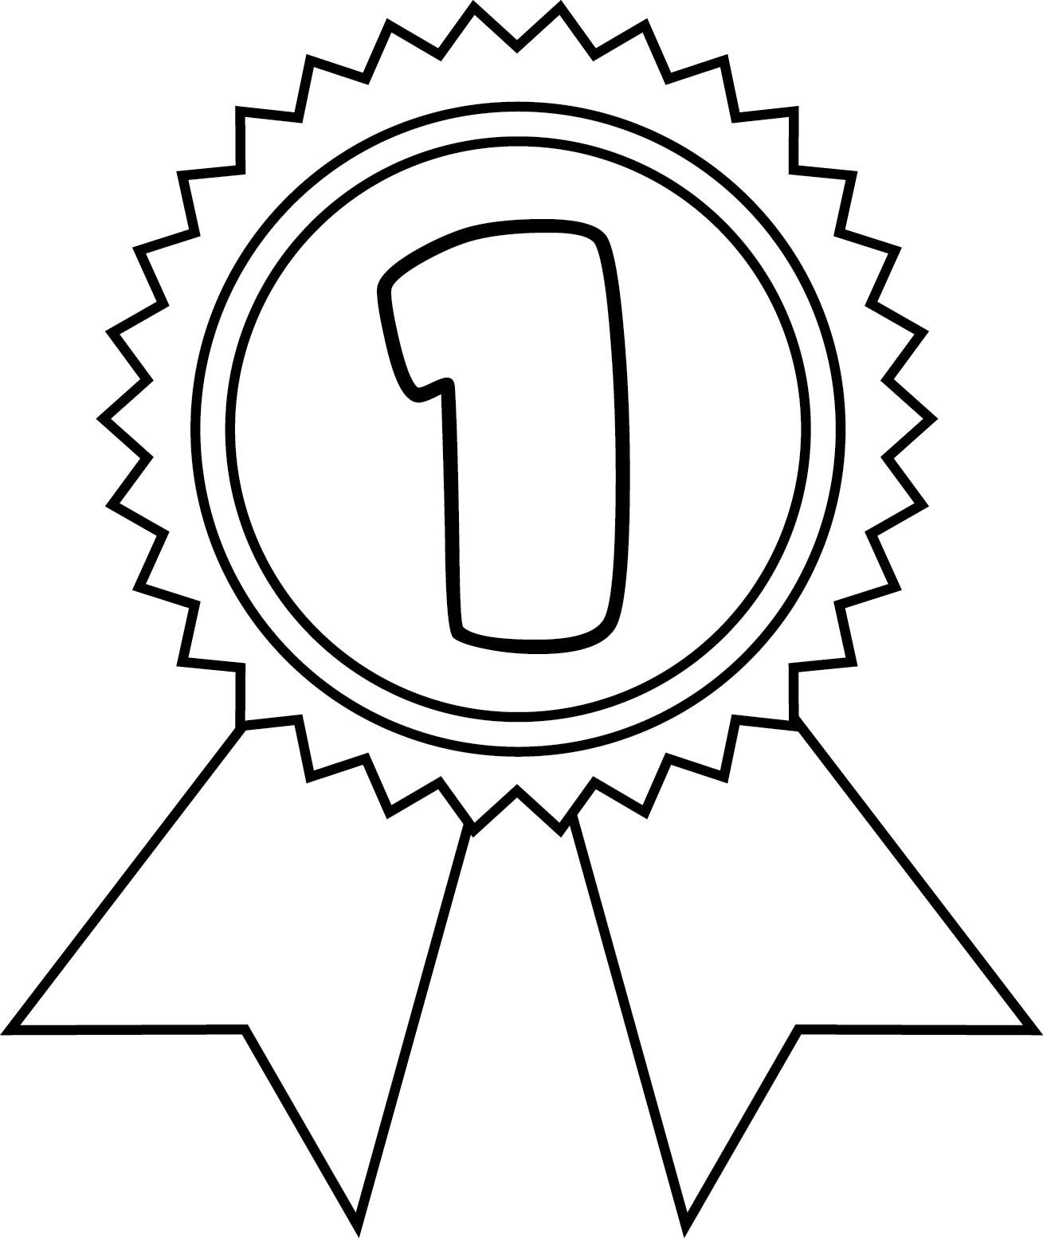
________________________________________________________________________________________________________________________

My Achievements

________________________________________________________________________________________________________________________

__________________________________________________________________________________________

My Best Friends

My best friends are: ____________________________________ ____________________________________________________________________________________________________________________________________________________________

