0

**North Duffield community primary school**

**progression**

**addition**

N

This document shows the progression in addition across school, covering all elements of **Concrete -> Pictoral -> Abstract** including formal written methods and mathematical vocabulary.

It is used alongside the Mathematics Framework

**Addition – Year 1**

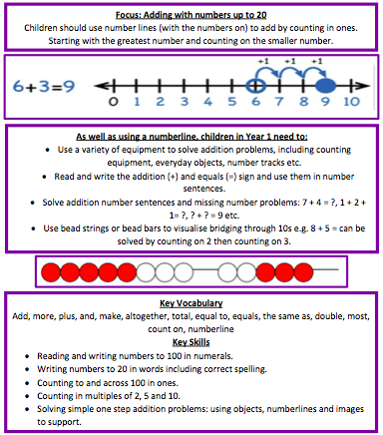

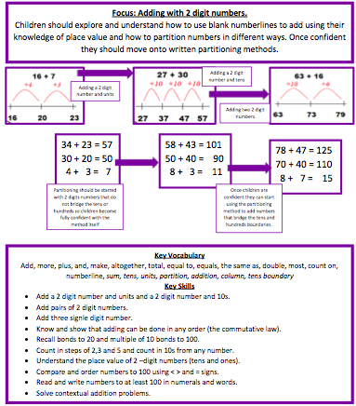**Addition – Year 2**

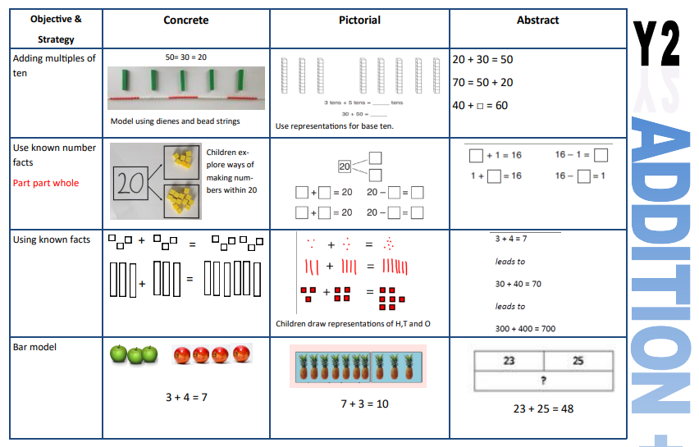

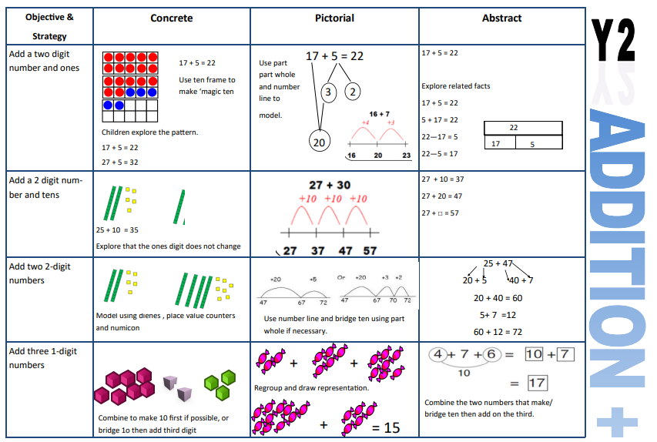

**Addition – Year 3**

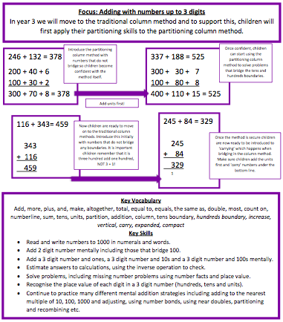

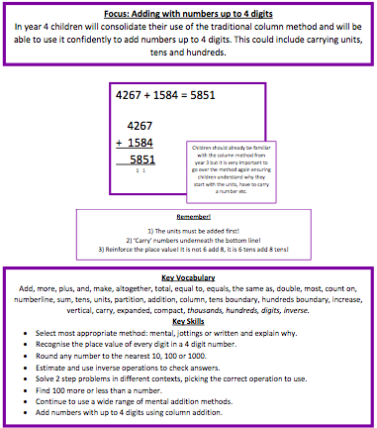**Addition – Year 4**

**Addition – Year 5**

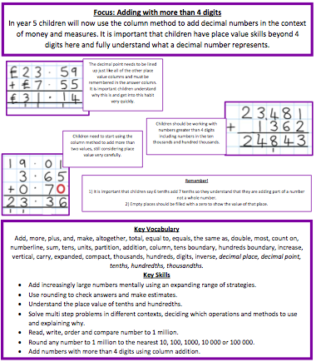

**Addition – Year 6**

