ICT/Geography  Can you use the internet if you have access to it, to find out where Grace Darling’s lighthouse home was?  Which country is it in?  For an extra challenge, can you tell me which county the lighthouse is in? | 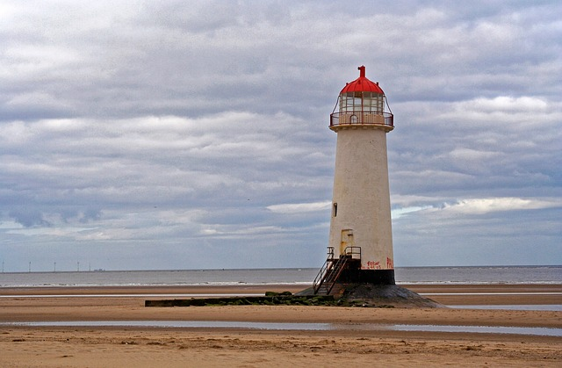 | History  Can you use the power point and any research of your own to write a fact file about Grace Darling?  When/where was she born?  Where did she live?  When did she die?  Why do we remember her?
Art/DT  Use some of the photos (below) of Grace Darling to create your own portrait of her.  You can use any media you would like and make it as creative as you want to! | Science  We are learning about Light and Shadows. Can you explain how a shadow is made in a full sentence and a diagram if you need one.  Fun challenge!  Look at the hand shadow puppets below the grid. How many of these animal shadows can you make with your hands? | Phonics/reading  Can you read the information about Grace Darling and answer the questions?  Look at the words highlighted in bold. Can you find a synonym for each one?
