Badger  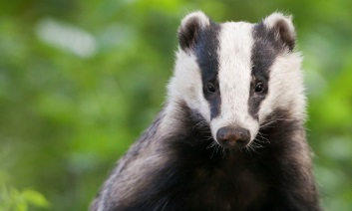  I eat worms, insects, small animals, fruit and mushrooms. | Robin  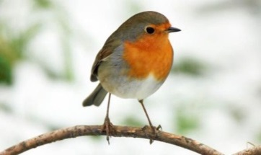  I eat worms, caterpillars, fruit and berries. | Cheetah  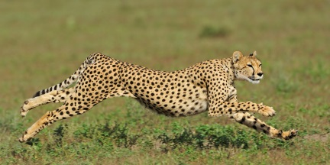  I eat zebras, gazelles, hares and birds. | 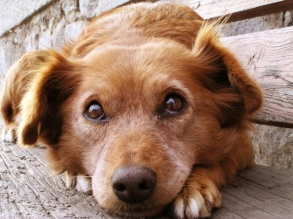  Dog  I eat dog food that has meat and vegetables in it. | 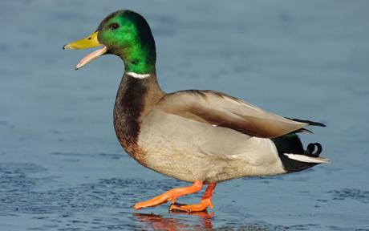  Duck  I eat seeds, nuts, plants, insects and small fish.
Horse  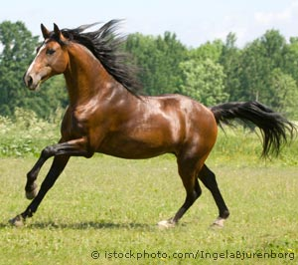  I eat grass. | 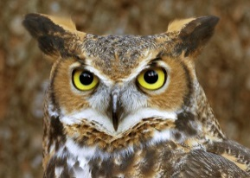  Owl  I eat insects, fish and small animals. | Squirrel  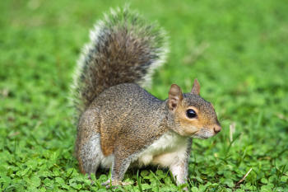  I eat nuts, pine cones, fruit, mushrooms and plants. | Cow  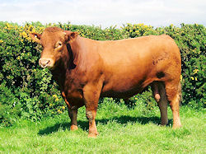  I eat grass. | 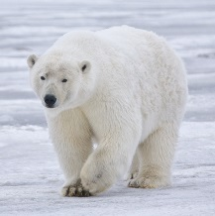  Polar bear  I eat seals, walruses and whales.
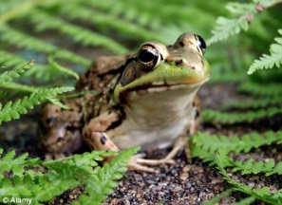  Frog  I eat insects and worms. | Crocodile  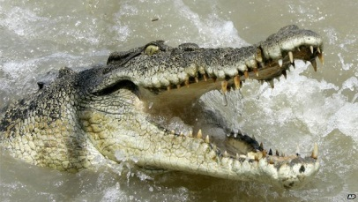  I eat fish and other animals I can catch. | 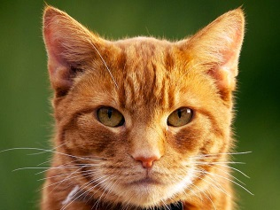  Cat  I eat cat food that has meat in it and mice and birds. | Trout  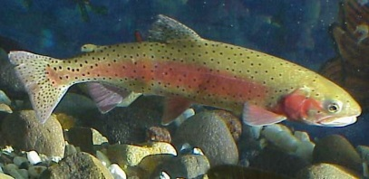  I eat insects and smaller fish. | 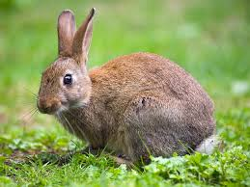  Rabbit  I eat grass, weeds and vegetables.

