History – Week 5 - To identify some of the main changes in Britain since 1948 and to identify key characteristics of different decades.

What do you think are the main changes to have happened since 1948? Give a minute to think and then discuss their ideas. Create a list of ideas. Encourage children to use higher-level vocabulary, e.g. population structure, increased consumerism, technological advancements, etc. and discuss the meaning of these words.
Show children the pictures on the slides. What decade is this from? How do you know? What does it show us about life in this era? How have things changed since this picture? How would you characterise each of these decades: 1950s, 1960s, 1970s, 1980s? Children to come up with a few adjectives for each using the pictures to help.

Ask children to read the information about the 1950s and create a Venn diagram to compare the 1950s to the present day, showing things that are different and things that have remained the same.
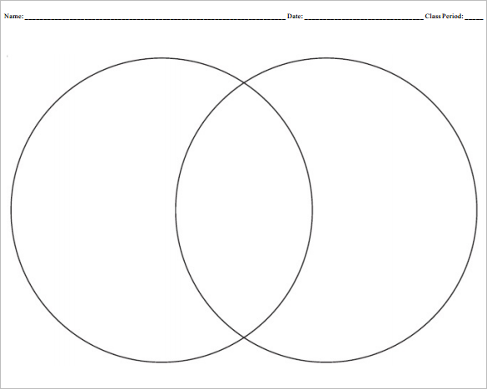

Extend:
Look at the inventions of the 1950s and choose an area to research and present your findings in either powerpoint or by creating an information page.

