Look at the ‘Fly the Flag’ slides.  Why do you think the RNLI and the lifeguards have different flags on the beach?  On the photograph of the lifeguard, she is carrying a large yellow object. What do you think this is used for? | 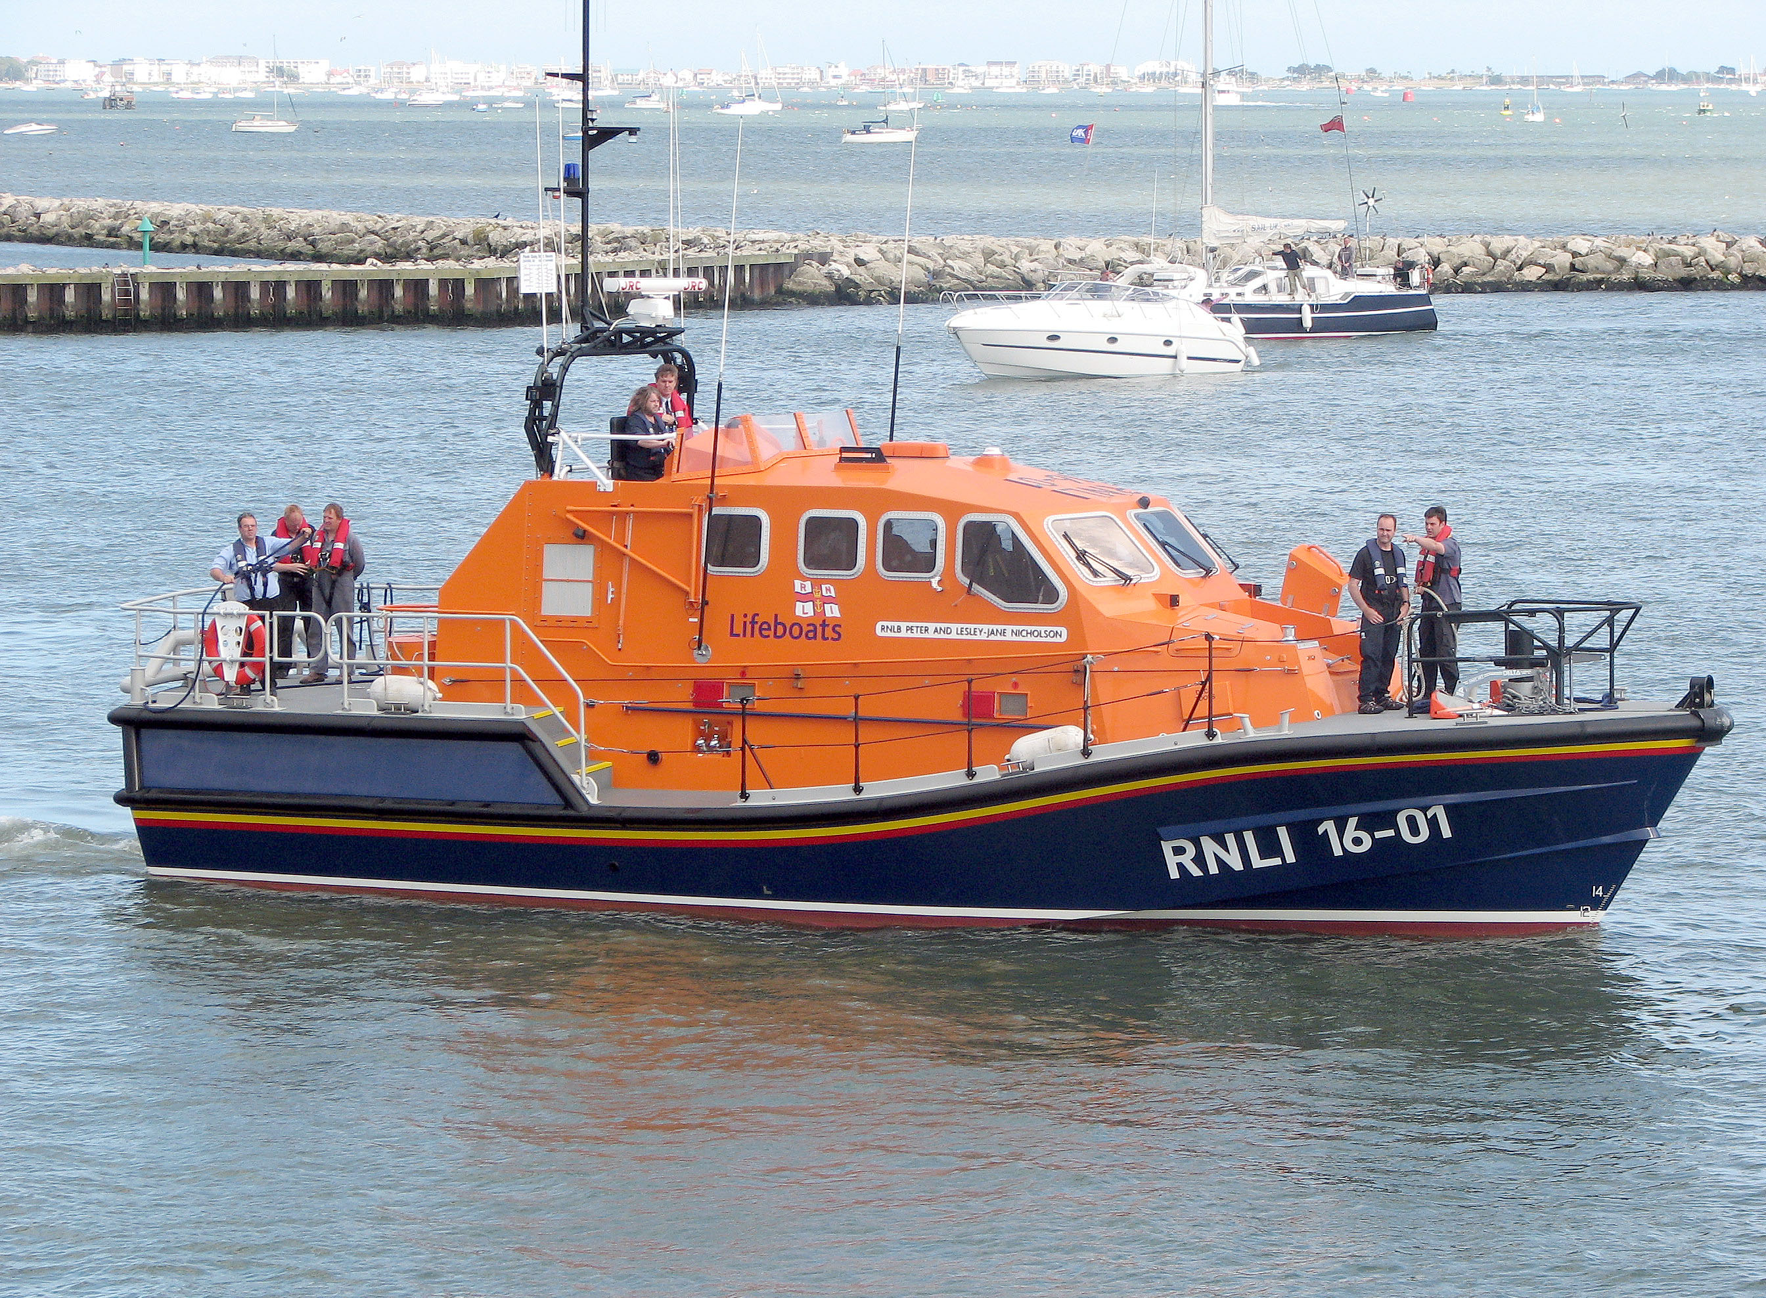 | Look at the ‘Fly the Flag’ slides.  Can you answer the questions about each flag?  What do they represent and when are they used?
Can you design your own flag for the RNLI or for the beach?  When would it be used and why?  What symbols could you use to represent water safety/lifeguards or the RNLI? | Science  Rainbows are formed when light shines through water, like when the sun shines through the rain. This light is bent and reflected, like a reflection in a mirror, and this causes all the amazing colors that you see. What makes rainbows so special is that no two people see the same exact thing. Since it all depends on how the light is being bent and reflected back to you, everyone sees something different.  Use the rainbow experiment to try and grow your own rainbow. | RS  Look at the slides about Rangoli patterns and read the information.  Can you design your own Rangoli pattern to invite the Goddess Laksmi into your home?  Remember, I’d love to see them!

