Do you know what the ‘RNLI’ is?  Investigate what the RNLI is, what does it do, why do we need it, what do the letters stand for?  As a challenge, can you tell me what the link is between the RNLI and Grace Darling?  This website links might help you:  https://rnli.org/what-we-do  https://rnli.org/youth-education/education-resources/videos | 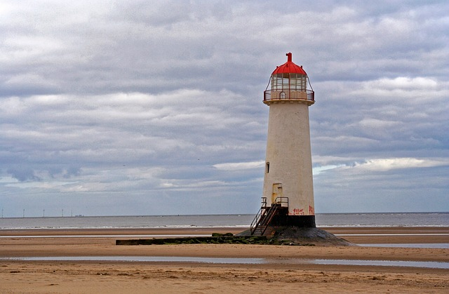 | History  Look at ‘lifeboats through time’  Can you answer the questions about lifeboats in the past and compare them with our modern lifeboats?
Art/DT  Origami is the art of paper folding. You can create many different objects and works of art using origami. You can only fold the paper, you cannot use anything to cut it or stick it together.  Use the ‘paper lifeboat’ instructions to make your own origami paper lifeboat.  You will need a piece of paper. | Science  I have really enjoyed looking at your shadow pictures and I’ve had great fun trying to work out what they all are. I’ve found some shadows of my own for you. They are the shadows of famous buildings, objects and characters. Can you work out what they are? | RS  Diwali is the festival of light and it is celebrated by Hindu’s all over the world.  Use the Diwali factsheet and key words to summarise the festival in your own words.  What happens?  What is celebrated and why?

Grace Darling
Soon the story of the wreck and the daring rescue was on the front pages of all the newspapers. Grace Darling became a heroine. Everyone wanted to know all about her, especially what she looked like.
Since there were no cameras in those days, many artists visited the lighthouse to paint Grace’s portrait.
For years after the rescue, the lighthouse was busy with visitors who wanted to see the famous Darling father and daughter.
Grace was sent hundreds of letters and presents.
She was often asked for a lock of her hair.
Both Grace and her father were awarded gold medals from the Royal Humane Society, and Silver Medals for Gallantry from the National Institution for the Preservation of Life from Shipwreck (now the Royal National Lifeboat Institution).
Even Queen Victoria sent her £50.

