Lighthouse Keeper’s Lunch
Read the rest of the story and use the text to complete these tasks.
Imagine you are one of the characters in the story.  How are you feeling and why?  How do you think Mr or Mrs Grinling will be feeling after what has happened?  Or, what will one of the seagulls be thinking and how will they be feeling after eating the horrible food?  Write your own diary extract or a letter to your friend to explain how you are feeling and what happened that made you feel that way.  Try and use some conjunctions such as,  because  when  if  that | 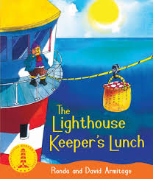 | Ooh those seagulls!  You are a seagull. You have been looking forward to stealing another tasty lunch. However, it has been replaced with horrible food that tastes disgusting!  Can you write the next part of the story from the seagull’s point of view?  Imagine you are the seagull and you’ve just eaten a mouthful of that horrible food. What did you do/say?
Naughty Mrs Grinling!  Mrs Grinling made mustard sandwiches for the seagulls.  What would you put in your sandwiches and in your picnic basket to stop the birds?  Can you write a set of instructions to make a horrible sandwich for the seagulls?  Remember to use your instructional language such as,  first, then, next, after, | Can you use the text to answer these questions in full sentences.  How does Mrs Grinling send Mr Grinling his lunch?  What happens at the beginning of the story?  What happens next?  What happens to Hamish the cat?  How do they stop the seagulls eating Mr Grinling’s lunch?  Vocab: Story, book, house, cliff, sea, lighthouse, lunch, basket, rope, seagulls, boat, mustard, | Can you order the events of the story?  What happened on each day of the week?  Can you write some sentences to explain what happened on each day of the week and illustrate it?

Topic tasks
History  Look at the slides about Holidays in the Past (we have used these in previous weeks)  Can you think of any similarities and differences between holidays that we have now and ones that they may have had in the past?  Are there any things that are the same?  Use your own knowledge and the slides to help you. | 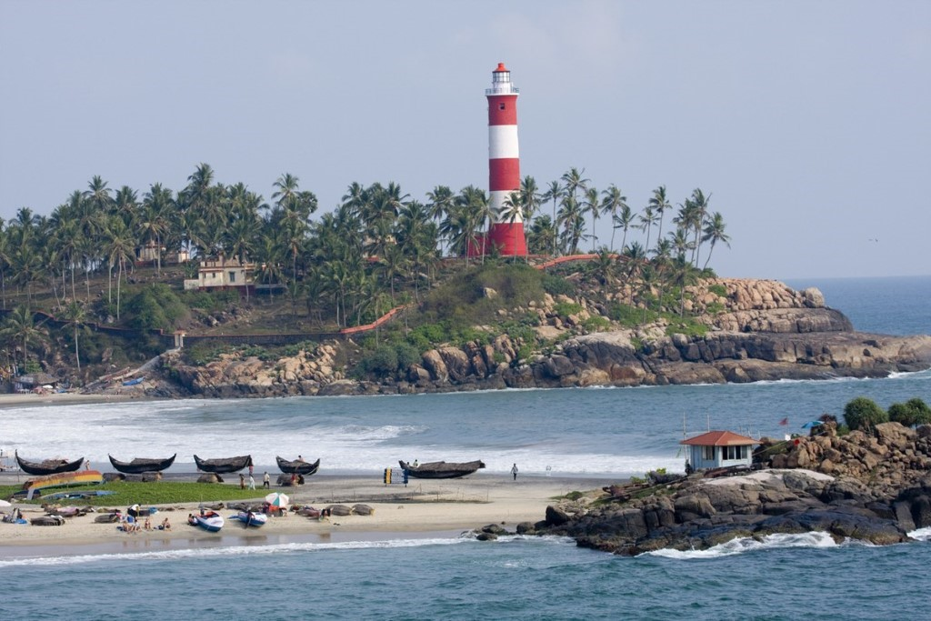 | Science  We have been learning about Light.  Do you know what a ‘shadow’ is and how it is formed?  Can you investigate how shadows are formed and write a sentence to explain it?  Can you make/draw some shadows of your own? Take a photograph of your shadows and email them to me, I’ll try and guess the objects for you!
ICT/Geography  You have been investigating Lighthouses from around the world.  Can you use Google Earth or other sources of information to find out, in which countries/continents these Lighthouses are?  Nubble Lighthouse  Lighthouse of Genoa (There’s a clue in there!)  Bug Light  Point Bonita  Flamborough (this one is easy!) | Phonics postcard  Can you read the postcard from Greece and find all the split diagraphs on the task sheet?  Can you extend your work by writing the words into sentences of your own? | Art/DT  Use the information and photos that we have been using in our learning, to create your own drawing of a Lighthouse.  What shape will it be?  How high?  Where would you build your lighthouse and what colour would it be?  Draw/paint/create your lighthouse and remember, that I’d love to see a photograph.

