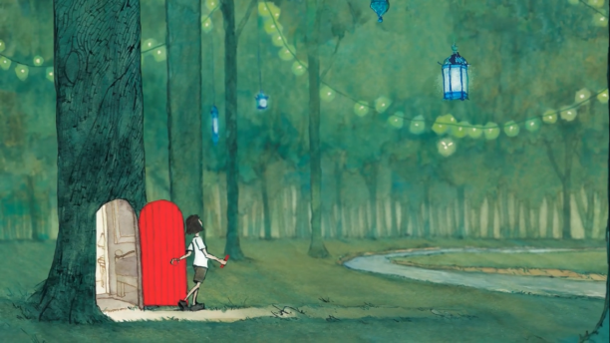
Journey activity
To start an adventure, you must walk through a door.
Draw your door.

On your adventure, you encounter a waterfall, and you’re about to go over the edge! Draw what you will use to escape.

After you’ve made it away from the waterfall, a monster is in your path! Draw how you will protect yourself.

Once you’ve defeated the monster, you find yourself at a cliff at the edge of a chasm. Draw how you will get across to the other side.

You’ve reached the other side, but your adventure doesn’t end there. Draw where you will go next.

