Home Learning Project – Class 3 Summer Term Week 10
This term we will be looking at WW2, especially being an evacuee and what it was like to live during the Blitz. Now that we have finished our class novel, Spywatch, we are moving onto poetry about WW2. These tasks are to be carried out over a week.
Weekly Maths Tasks |  | Weekly Reading Tasks
White Rose Maths  Please continue to work your way through the White Rose Maths sessions that are uploaded to the website.  General  Play a maths game on https://www.topmarks.co.uk/maths-games/hit-the-button  Times tables Go on TTRockstars |  | Read the Evacuee poem on the website and answer the questions relating to it.  Read a book on Oxford Owl https://www.oxfordowl.co.uk/.
Weekly Spelling and Grammar Tasks |  | Weekly Writing Tasks
Spellings  Using the Y3/4 Common Exception words which are uploaded to the website, pick another 10 that you find more difficult to remember in your writing and then carry out the following activities:  Create a word doodle with your spellings.  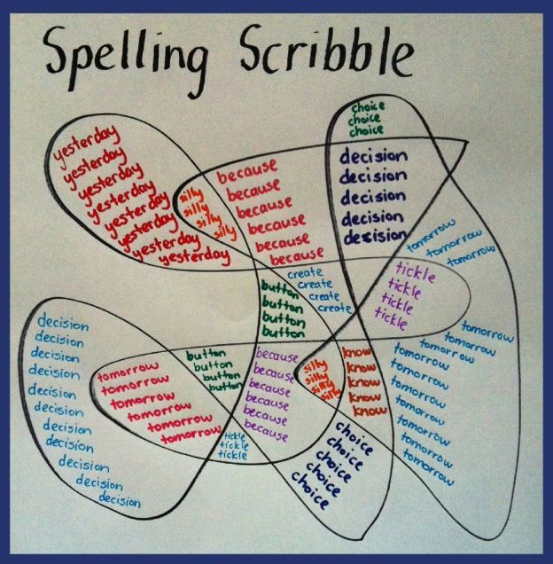  Write your spellings 7 times using 7 different colours.  Write a sentence for each of your chosen spellings.  Type up your spellings and change the font, size and colour of them.  Grammar activities are now added to the website. Please work your way through them. |  | We are moving onto poetry writing which I know you are all so good at.  Open the PowerPoint and you will find the writing task at the end of it.  I LOOK FORWARD TO READING YOUR POEMS.
Topic Learning - to be done throughout the week (this links to the Learning Overview on the school website)

French  Please continue to log onto the website below and have a go at the lessons. Work your way through – the first few sessions should be a recap of the work we have completed in class.  https://www.duolingo.com/  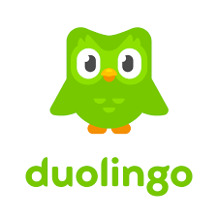 | Computing  Keep going with the programming and coding. If you haven’t already, visit https://code.org/hourofcode/overview and choose a game to work through.  Once you are confident, try coding for yourself at www.scratch.mit.edu by pressing the ‘create’ button at the top. Maybe create a game that you need to catch WW2 bombs falling form the sky.  Try to add a counter to keep score. How about adding more than one player?  There are many useful help tutorials in scratch that could help you.
History / PSCHE  We have been lockdown for over 13 weeks now – what have you done? What has it been like for you and your family?  Your task this week is to complete the cards on the website and place them, along with any other memories, into a time capsule (box/bottle etc). When your grandchildren ask what it was like during the 2020 Pandemic you can bring it out to show them. | Art  We now need to make our own matchstick painting based on Lowry’s work. Can you create a drawing/painting that reflects your experience of lockdown but represented in matchstick images.  I would like to create a ‘Snake of hope’ to snake around the village. Please could you paint a rock and place it at the end of the ‘snake’ that we have started at the entrance of school. Please pass this on to your friends and neighbours and lets see how far we can go around the village.  Ribbons of Hope – I recently saw this at park near to my house and the key worker children have been practising their knot tying. They have tied lengths of ribbons to posts that are at the entrance of school. Please feel free to untie these and relocate them on the school fence.
Additional activities and learning resources you may wish to engage with
- Practise your hopping. How long can you hop for before you put your foot down. Try to beat your time each day.
- Log on to Cosmic Kids Yoga and choose one of the yoga stories. Why not try this one Wizard of Oz version! https://www.youtube.com/watch?v=j_3weVPH0-U&vl=en-GB
- Go Noodle session. Choose your favourite three Go Noodles and have fun! https://www.youtube.com/channel/UC2YBT7HYqCbbvzu3kKZ3wnw
- Joe Wicks. Complete the daily workout.
- Set up an obstacle course in your house or garden (if the sun is shining)

Classroom Secrets Learning Packs
https://classroomsecrets.co.uk/free-home-learning-packs/ These packs are split into different year groups and include activities linked to reading, writing, maths and practical ideas you can do around the home.

Twinkl https://www.twinkl.co.uk/offer/UKTWINKLHELPS?utm_source=promo&utm_medium=email&utm_campaign=England_coronavirus_schools_email&utm_content=offer_link to access these resources click on the link and sign up using your own email address and creating your own password. Use the offer code CVDTWINKLHELPS.

Hamilton Home Learning Packs
https://www.hamilton-trust.org.uk/blog/learning-home-packs/ this website has English and Maths home learning packs available to download.

James Dyson Foundation
https://www.jamesdysonfoundation.com/resources/challenge-cards.html for all you engineers! A full pack of engineering activities do to at home.

Joe Wicks PE lessons https://www.youtube.com/channel/UCAxW1XT0iEJo0TYlRfn6rYQ?safe=true The Body Coach has announced that he will be doing free PE lessons Monday – Friday on his Youtube channel.

