Literacy/Topic

Watch the 10 Minute Challenge by J.M. Joseph on Authorfy: https://authorfy.com/10minutechallenges/

You will use this challenge to plan and write a narrative. I would like you to link this to your learning on World War I – the mystery package could be sent to a soldier on the front lines in Europe, or maybe a soldier has sent a letter back to a family member or friend. Use the narrative as a chance to show off both your writing skills and your knowledge of the topic.

If you are unable to access the video, it asks you to create a mysterious package. When the package arrives, the receiver should take their time opening it and build the suspense. What could be inside? What does it feel like?
The package contains a magical object. What does it do? Does it transport the receiver somewhere else? Does it let them ‘see’ what the sender is doing at that very moment? Is it a powerful object?

Use this scene as the basis for your narrative.

Spellings

Continue with the next set of spellings. The resources for these can be found in the home learning content for Weeks 3 & 4.

Maths

https://whiterosemaths.com/homelearning/year-6/

Complete Summer Term Week 3. These lessons are a recap of the fractions work that we did earlier in the year.

Music

Look at the music lesson on BBC Bitesize: https://www.bbc.co.uk/bitesize/articles/zkx3bdm

Have a go at activities 1 & 2. Alongside activity 2, I will try to learn Somewhere Only We Know on the piano over half-term in the hope that we may be able to form a socially distanced Year 6 choir in the near future.

If you are unable to access the website, please see the screenshot below for activity 1.
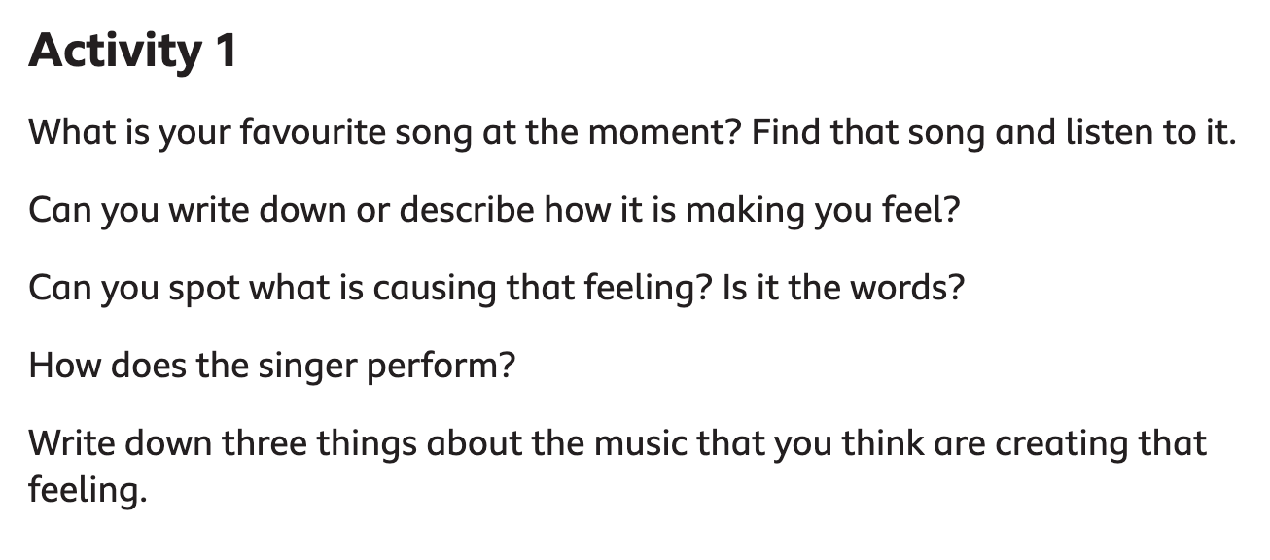

The song to learn in activity 2 is Somewhere only we know by Keane/Lily Allen.

Reading

Continue to read The Skylark’s War. If you still need a copy, they are available to collect from school. Choose a character and plot their storyline so far on an emotions graph.

