Name:________________________ Date:____________________

Hindu Gods – Matching Activity

Saraswati  Goddess of knowledge, music and art.  Wife of Brahma. Usually dressed in white which means purity. She also is shown with a musical instrument and swans. |  | 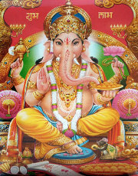
Kali  Goddess of time and death who brings disease and war.  Often seen with ten arms with a blue body and red raging eyes. She wears a skirt of humans and a necklace of human skulls. |  | 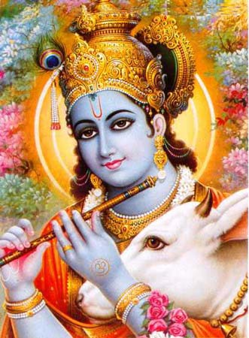
Ganesh  God of success and remover of obstacles. He is very wise and known as the elephant god because he has an elephant’s head and big belly. He is a popular god. He is seen with a mouse. |  | 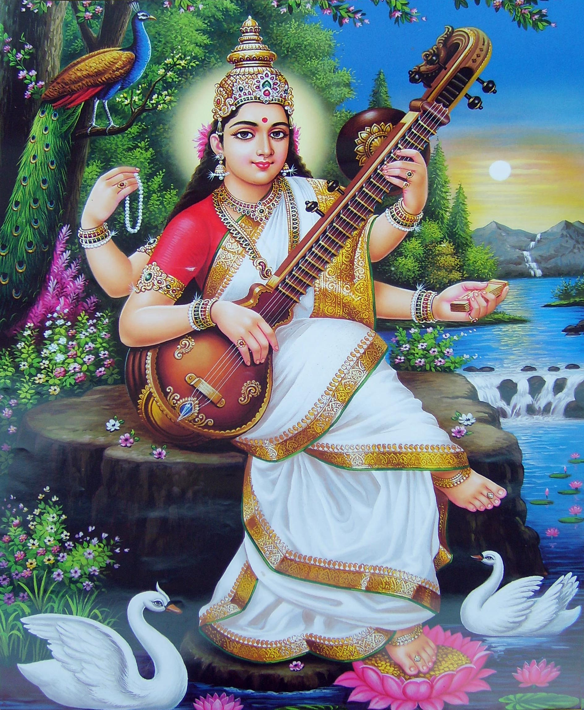
Krishna  Was a God who became a man to show people on earth how to live. He taught many lessons so is now known as the God of Knowledge. He is often blue and plays a flute. He is shown as being young and has cows in his portraits. |  | 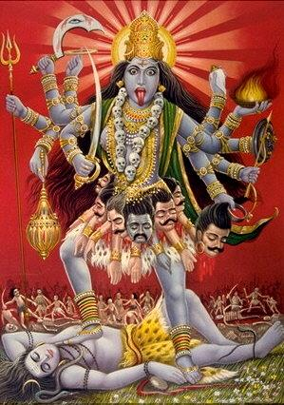

Lakshmi  Goddess of wealth and good fortune. She is pictured sitting on a lotus flower with a beautiful, kind and precious face. She will only visit homes of people who are clean in their homes and thoughts. |  | 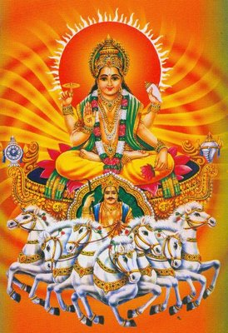
Surya  God of the Sun. Usually in golden colours riding a chariot with seven horses. The seven horses represent the seven colours of the rainbow. The Sun God has lots of temples and festivals in India. |  | 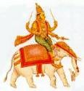
Indra  King of the Gods and god of rainfall and weather. Indra rides an elephant and holds weapons. He is a symbol of courage and strength. |  | 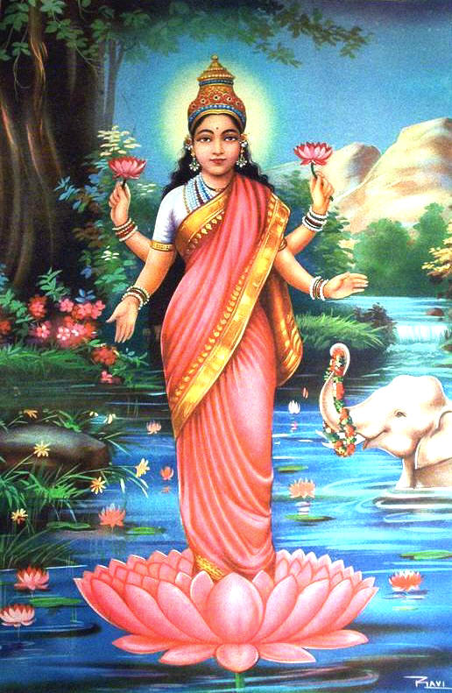
Vishnu  Vishnu is the god responsible for looking after the universe – the Preserver. He is usually light blue with four arms. He is one of the most important Gods in the Trimurti. Because he is so important he wears a crown usually with a peacock feather just like his son Krishna. |  | 

