Geography  Investigation challenge.  Can you find out where the nearest lifeboat station is to North Duffield?  What is it called?  What is it near?  Which county is it in?  How many lifeboats are at the station? | 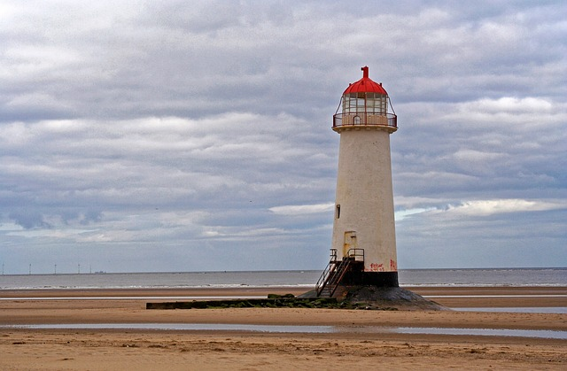https://rnli.org/what-we-do  https://rnli.org/youth-education/education-resources/videos | History  Look at the picture of the first lifeboat.  What do you think the dangers would have been for the crew who sailed in it?  What problems do you think the crew may have met when they were using it?  Did you know that the first purpose-built lifeboat in the UK was the result of a ‘design a lifeboat’ competition?
https://rnli.org/what-we-do/lifeboats-and-stations/our-lifeboat-fleet  Look at the RNLI’s fleet of lifeboats.  Why do you think they are different?  Can you design a lifeboat of your own and describe the job it would do? | Science  Rainbows are formed when light shines through water, like when the sun shines through the rain. This light is bent and reflected, like a reflection in a mirror, and this causes all the amazing colours that you see. What makes rainbows so special is that no two people see the same exact thing. Since it all depends on how the light is being bent and reflected back to you, everyone sees something different.  Use the rainbow experiment to try and grow your own rainbow. | RS  Read the story of Rama and Sita.  Can you use the information to answer these questions?  - What was Rama’s wife called?  - What was the demon king called?  - How many heads did he have?  - What was the monkey king called?  - Why was Sita happy in the end?

