We have been learning about Seaside holidays in the past and Lighthouses.
Did you know that there is a very famous person called, ‘Grace Darling’ who lived in a lighthouse?
Look through the slides on the power point to find out more about this very brave lady.
You can see inside her lighthouse here: https://www.bbc.co.uk/cbeebies/watch/my-story-grace-darling
If you met Grace Darling, what would you want to ask her and why?  Can you write at least four questions that you would want to ask Grace Darling?  Don’t write the answers, you may find that we find out the answers through our investigations and learning! | 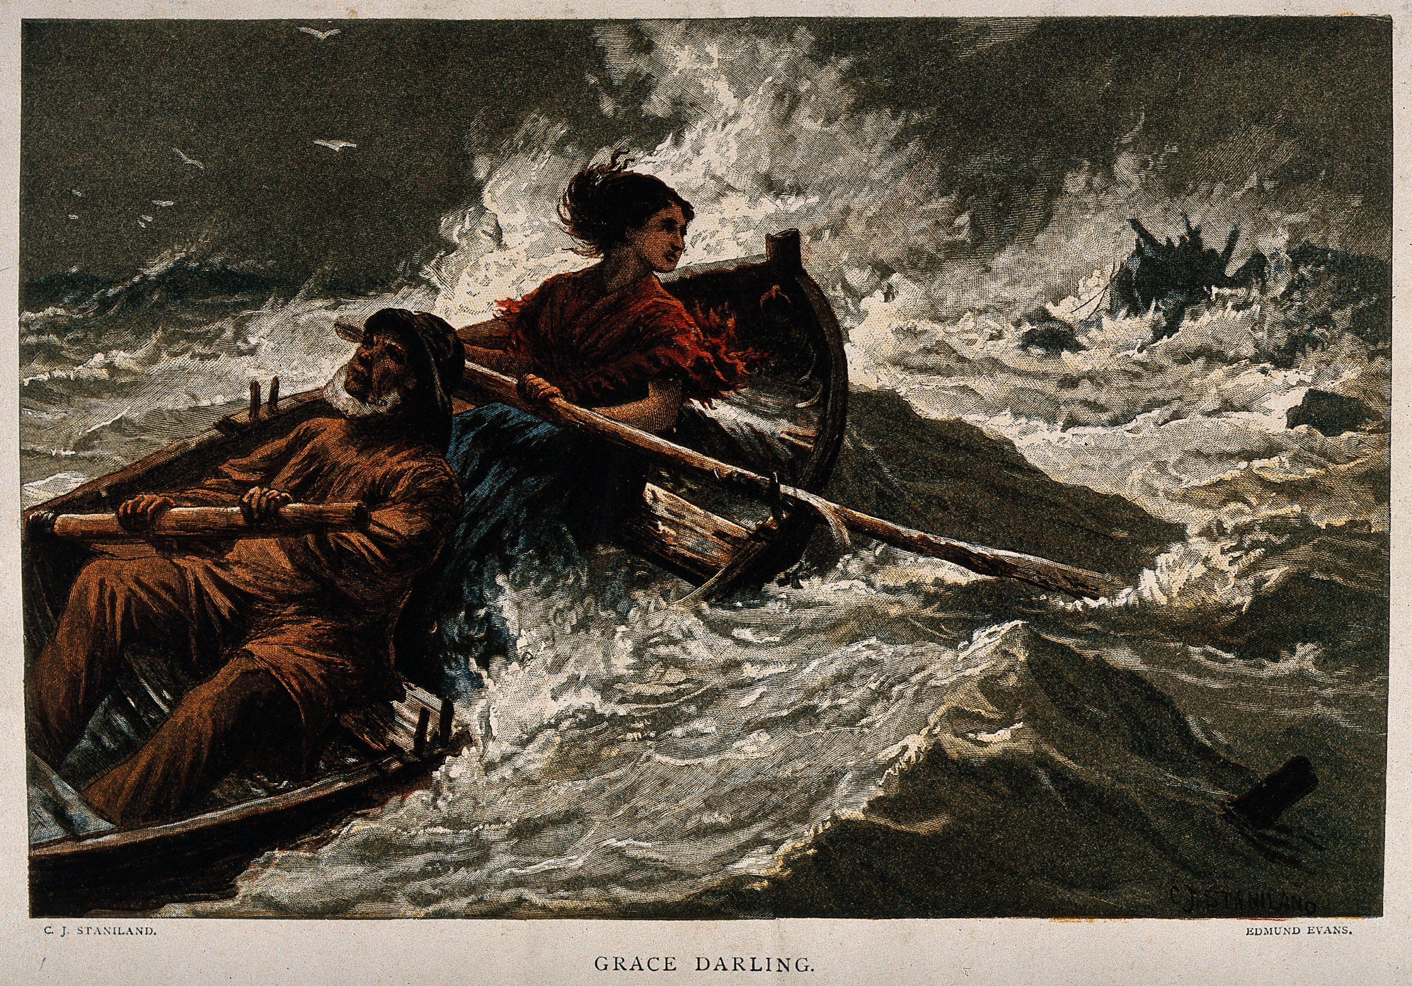 | How do you think Grace would have been feeling on the night of the rescue?  Write a list of adjectives to describe how she may have felt. Try and find synonyms for some of your words to make them more interesting.
Use the power point slides and the photograph of the rescue to imagine what the sea/the boats/the lighthouse would have been like.  Try and write at least 3 similes to describe them.  Eg;  The sea was as cold as ice.  The wind was as fierce as a lion. | You are going to write a diary extract from Grace Darling about the night of the rescue. However, you must plan it first.  Use the plan grid to help you and don’t forget those adjectives and similes that you have already written down! | Can you use your diary plan to write your own descriptive diary extract from Grace Darling?  Remember:  - Start with 'Dear Diary’.  - Describe the places where the events happened.  - Write in the past tense.  - Use pronouns like I, my and me to show that the events happened to you.  - Talk about how you were feeling or what you were thinking when each event happened.  - Use interesting vocabulary.

