Lifeboats through time
- Look at these pictures of lifeboats.
- How have they changed throughout the years?
- What are the similarities and differences between them?
- As a challenge, can you tell me why you think they have changed and what other factors have enabled those changes?
Eg; The new lifeboats have engines in them because of the developments in technology.

Lifeboat in 1802
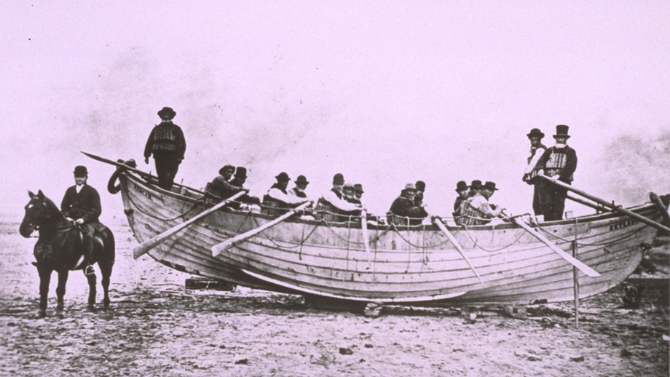
Lifeboat in 1892
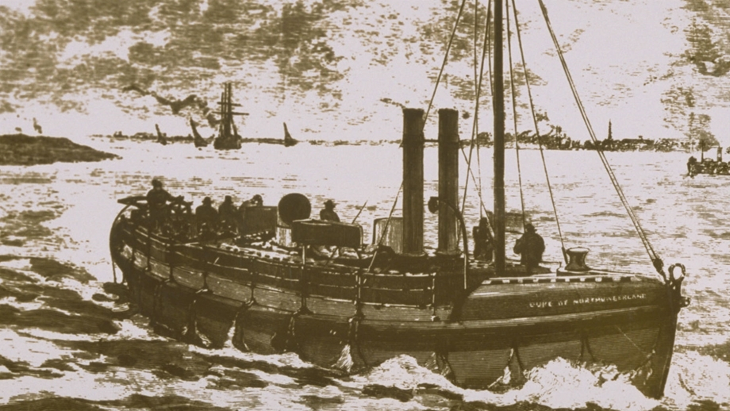

Lifeboat in 1903
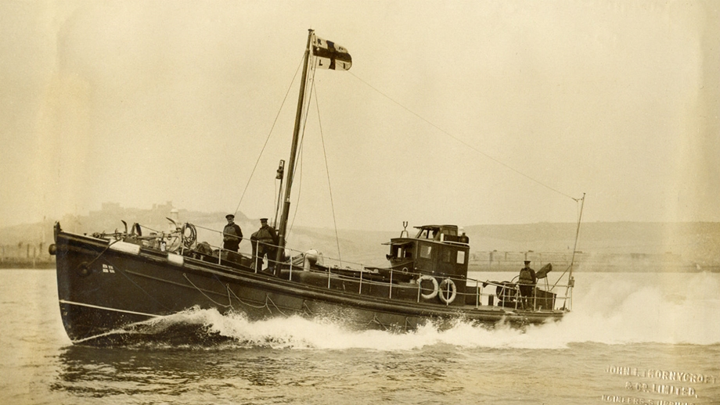

Modern lifeboat
