Statements  A statement is a sentence that tells you something.  For example: Grace Darling rescued sailors.  Look at your information slides about Grace Darling. Can you find any examples of statements in the text?  Highlight the ones that you can find. As a challenge, can you write at least three of the statements in your own words? | 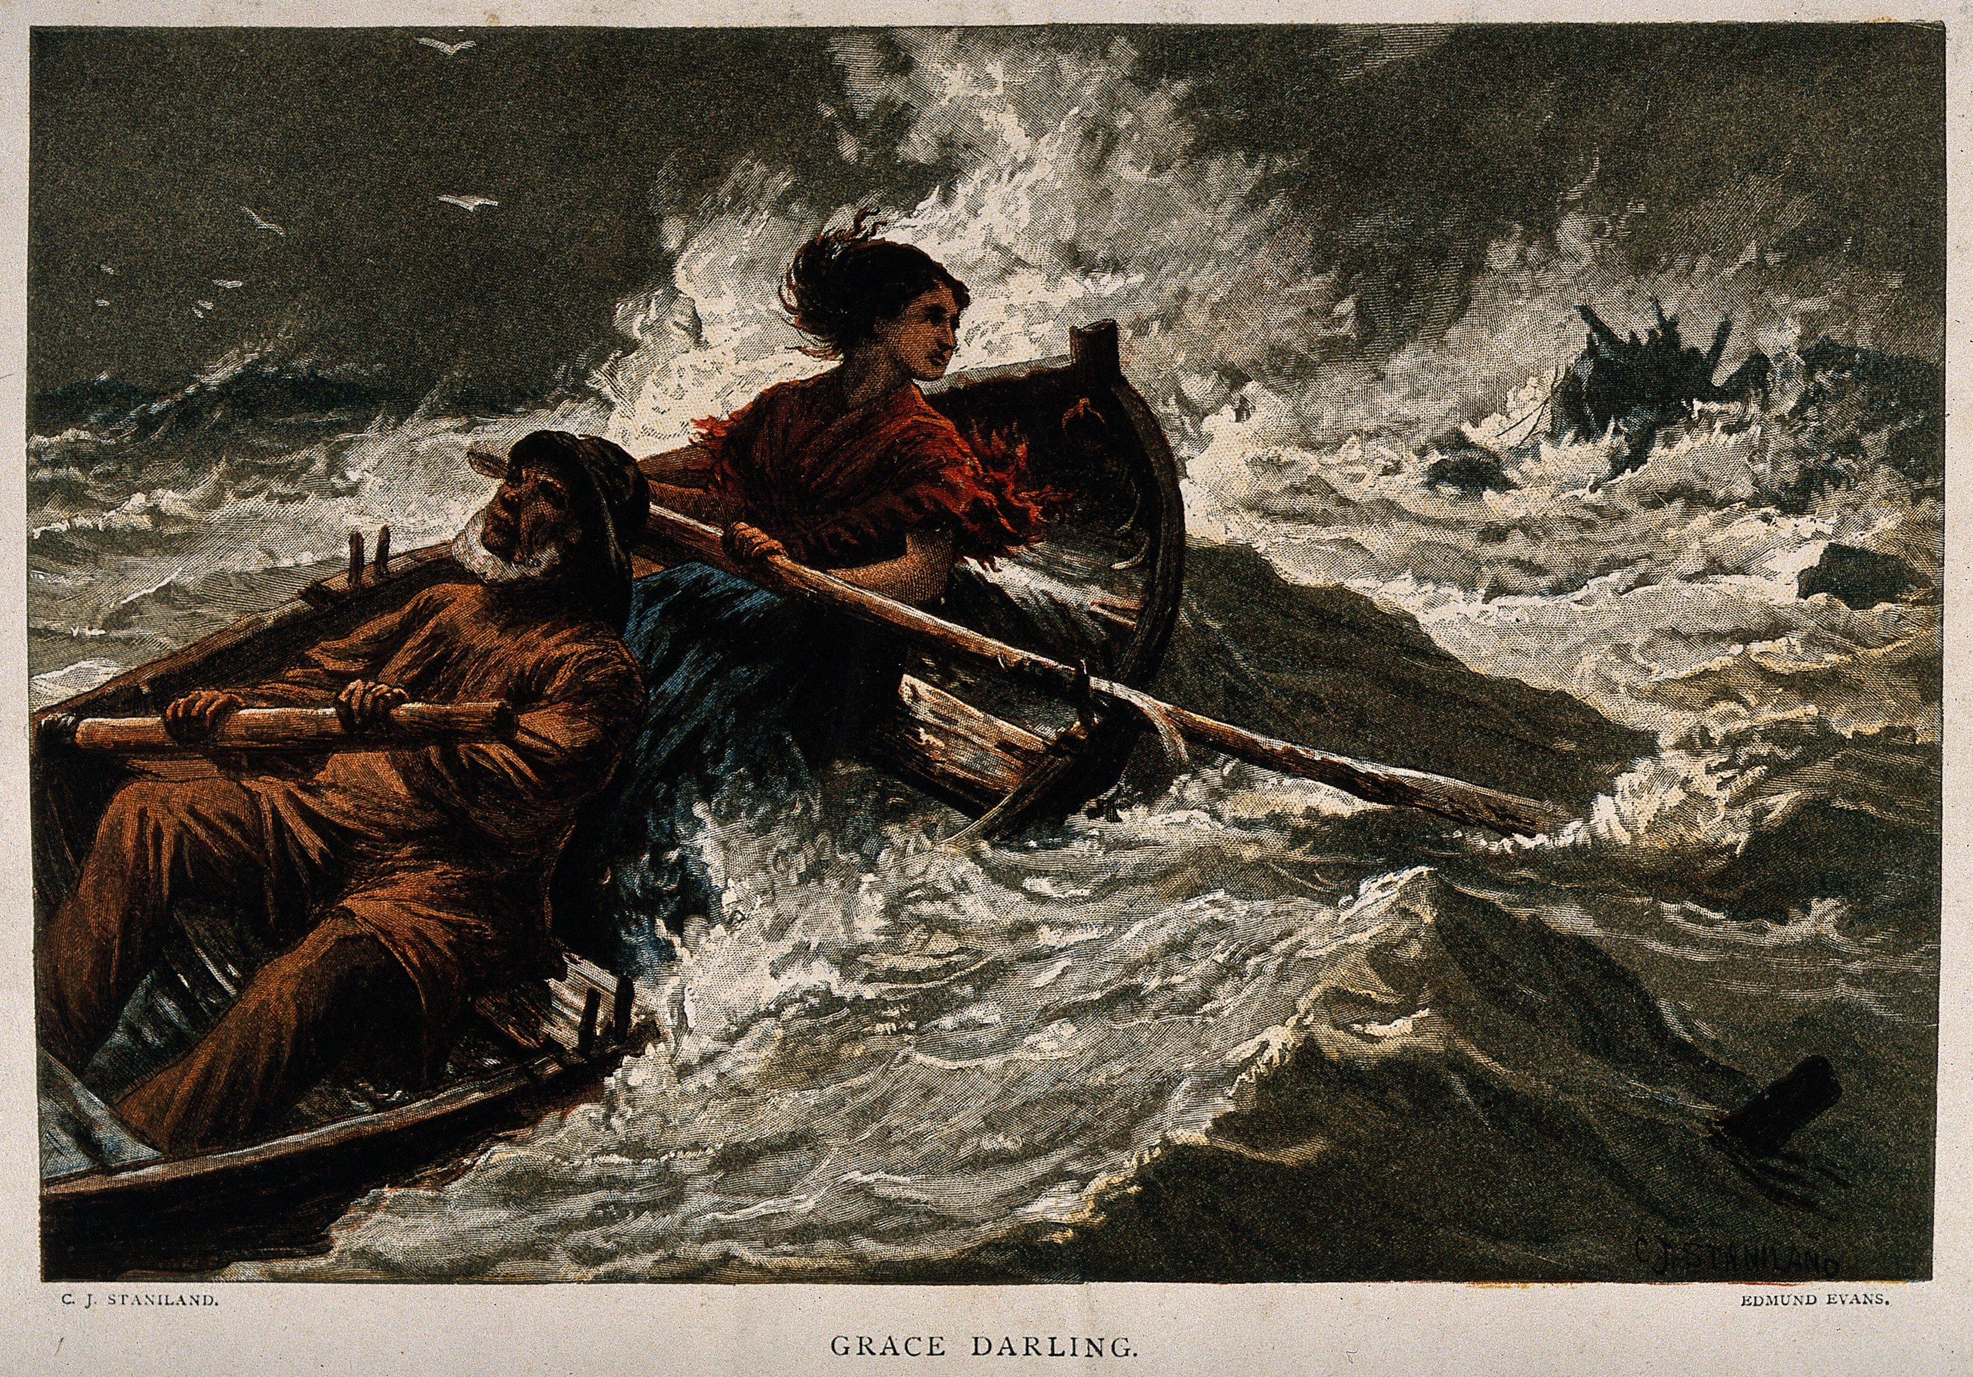If you have access to the internet, watch this video as it may help you.  https://www.bbc.co.uk/teach/class-clips-video/true-stories-grace-darling/z4y7pg8 | Statements.  Look at the statements that you have found in the information slides.  Can you use these statements and any facts that you have already learnt, to write 5 of your own statements about Grace Darling or the night of the rescue?
Can you use your statements about Grace Darling to complete an interesting fact file about her?  You will need to use your information slides to help you.  You could include when she was born, where she lived, when she died and why she is famous.  Remember to add interesting details about her life and the rescue. | Imagine you work for a newspaper.  What questions would you like to ask Grace Darling?  What would you ask about the rescue and her life?  Write 5 questions to ask her. Remember that you need ? at the end of each one.  Who  What  Why  Where  When | Use your imagination to try and answer your own questions about Grace Darling.  Pretend you are Grace and you are answering the questions for a newspaper.  For example:  Newspaper: Grace, how did you feel when you rescued the sailors?  Grace: I felt scared because it was dangerous to be out in the storm.  If you are stuck for ideas, email me some of your questions and I will pretend to be Grace to help you!

