Adverbs  An adverb describes a verb. A verb is a doing word.  Can you look at the photo on your sheet and write some adverbs to describe how the children played.  The children played happily.  The children played excitedly. | 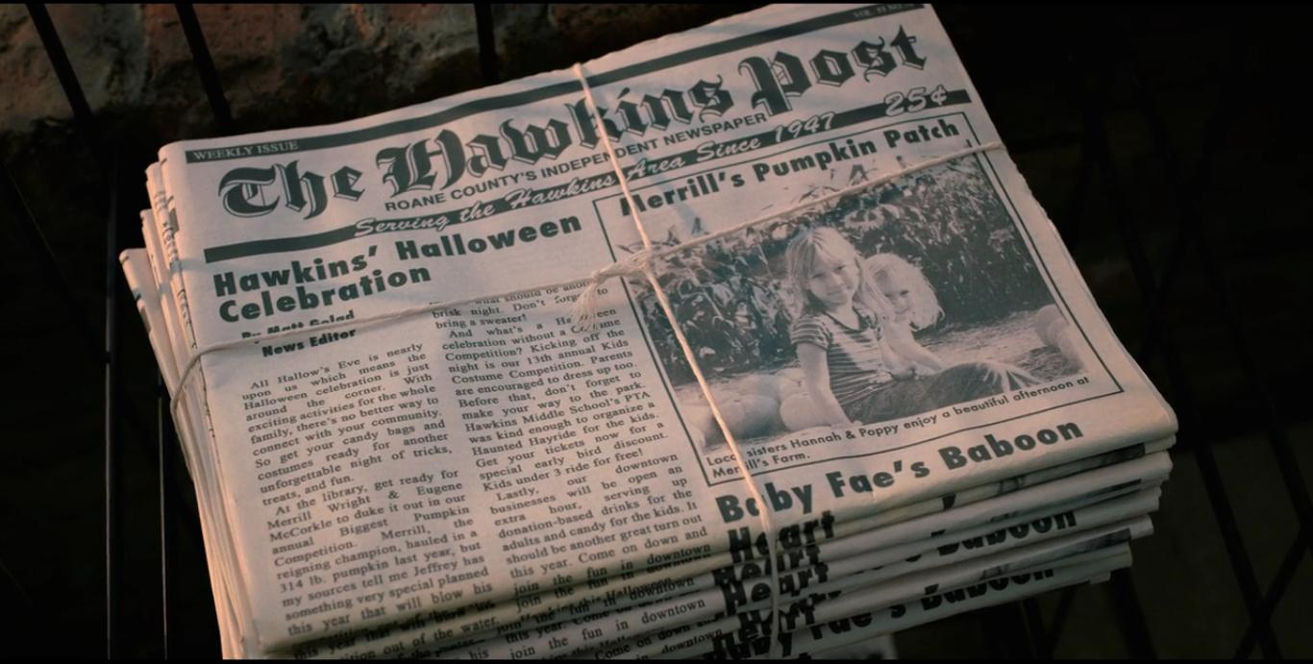 | Adverbs  In some of the newspaper reports that we have looked at, the reporter has used adverbs to add description. An adverb describes a verb, it can also describe when and where something happens.  Can you complete ‘adverbs 1’ by finding the adverbs in the text?
Use the work you have done about adverbs to write 3 sentences about Grace Darling.  You will need to think about what she did and how she did it.  You will be able to use these sentences to make your newspaper report sound more dramatic.  ‘Grace bravely rowed the boat out to sea.’ | Last week, you should have written a plan for your newspaper report about Grace Darling.  Use your plan and the work we have done to create your own newspaper report about the night of the rescue.  I would like to see some adverbs, a heading, a subheading and a picture (photo).  You can also add your own eye-witness accounts from the people who were rescued or someone who saw the rescue. | Every newspaper has an editor.  Find out what the role of an editor is.  What do they do?  How do they do it?  Can you pretend to be the editor of your newspaper and check your own report?  How can you make it better? Will your readers find it interesting?  Have you told the whole story?  Look at your language. Have you used adverbs, synonyms or similes to make you report sound more exciting?

