The Story of Grace Darling
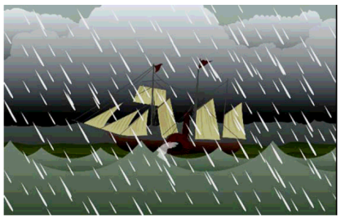
On 7 September 1838, a steamship called the SS Forfarshire was sailing from Hull to Dundee. The ship’s engines were not working properly and the Forfarshire was tossed on big, angry waves in a very bad storm.

- Where was the steamship sailing to?
London | Dundee
Portsmouth | Hull

Suddenly a big wave swept the ship up into the air and it crashed onto the Big Harcar rock. Grace looked out from her lighthouse. She said “I have to help them!” Grace rowed out with her father, William, to rescue them. He climbed onto the rocks to help the survivors and Grace waited in the boat, holding it steady even though the sea was very rough.

- What did Grace do whilst her father climbed onto the rocks?
Looked out of the lighthouse | Swam to the survivors
Waited in the boat | Went home

- Why did Grace say “I have to help them”?
______________________________________________________________________________________________________________________________
Grace and her father took them back to their lighthouse and looked after them for three days, until the storm finished.

At the same time, the local lifeboat crew also went out to save the people on the rock. It took them a long time to get there because of the terrible weather, so when they arrived all the survivors had already been rescued.

- Who had already rescued the survivors?

Florence Nightingale | Grace and her father
The local lifeboat crew | Dave and Bill

- What do you think Grace and her father did when they were looking after the survivors?
______________________________________________________________________________________________________________________________

Grace became a heroine. Even Queen Victoria heard about her bravery and sent her £50 as a reward. Many people sent her money and presents. She was also given two medals for her bravery.

- Why did people send Grace Darling money and presents?
______________________________________________________________________________________________________________________________

