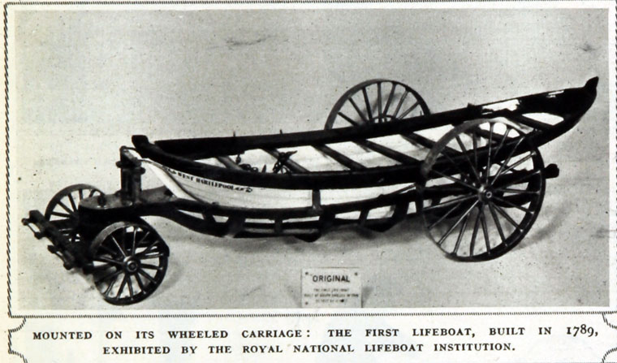

This is a photo of the first lifeboat, built in 1789.
It was designed by a man called Henry Francis Greathead.

