All about…..

Miss Williams

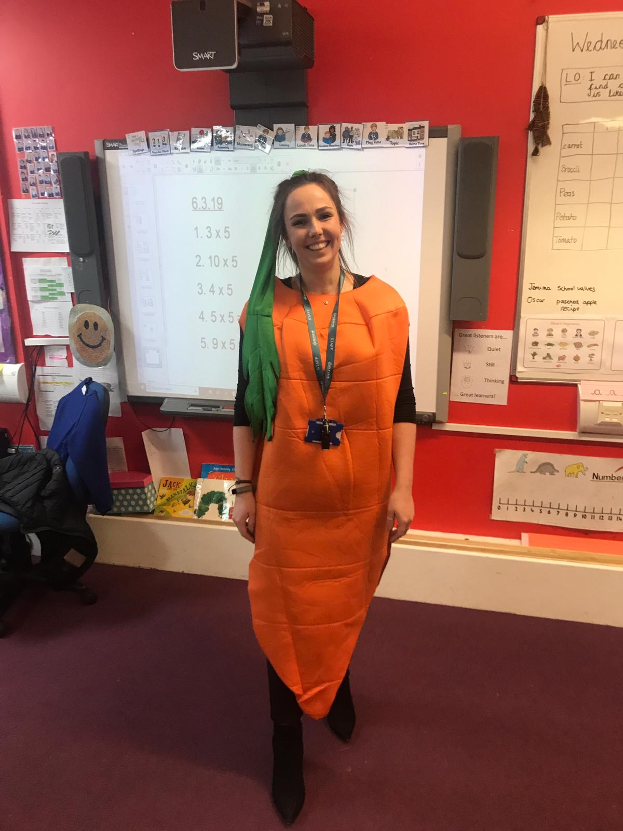

Please return to school by –
Tuesday 8th September 2020
Note to parents:
What makes me unique?
How you can use this bookl

My name is Miss Williams

I like to be called Miss Williams

My birthday is 1st August

I live in York

My favourite ‘toy’ is my cookbooks so that I can cook delicious foods.
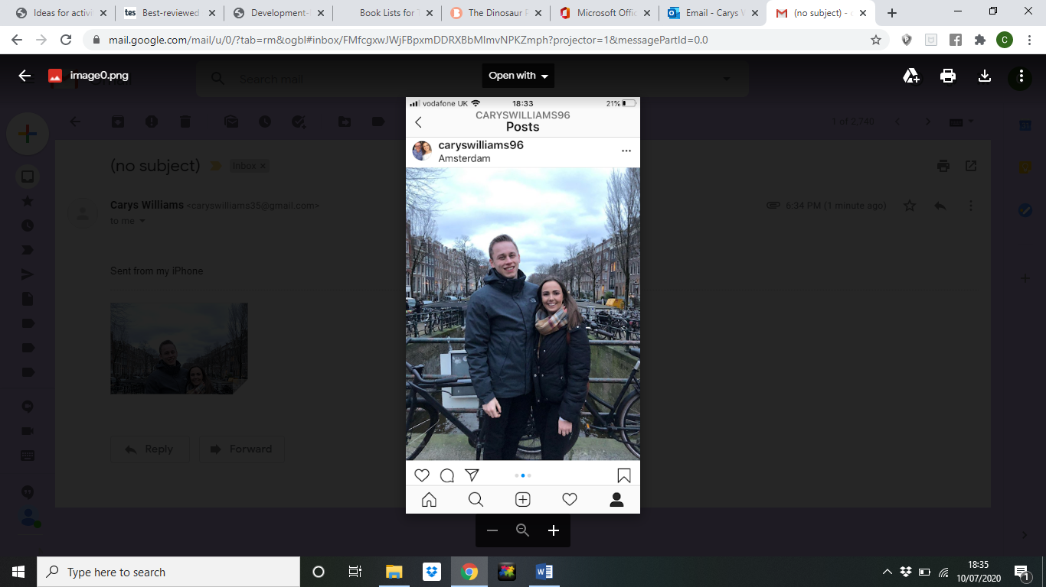
My brother
All of my grandparents
The family dog
Who lives in my house?
My sister
Other special people in my life…
My mum

It would be useful if you could bring in some family photographs so your child can also see pictures of these special people in our setting.
My Personal Thoughts

My Family

Please include some family photographs or drawings of family members.

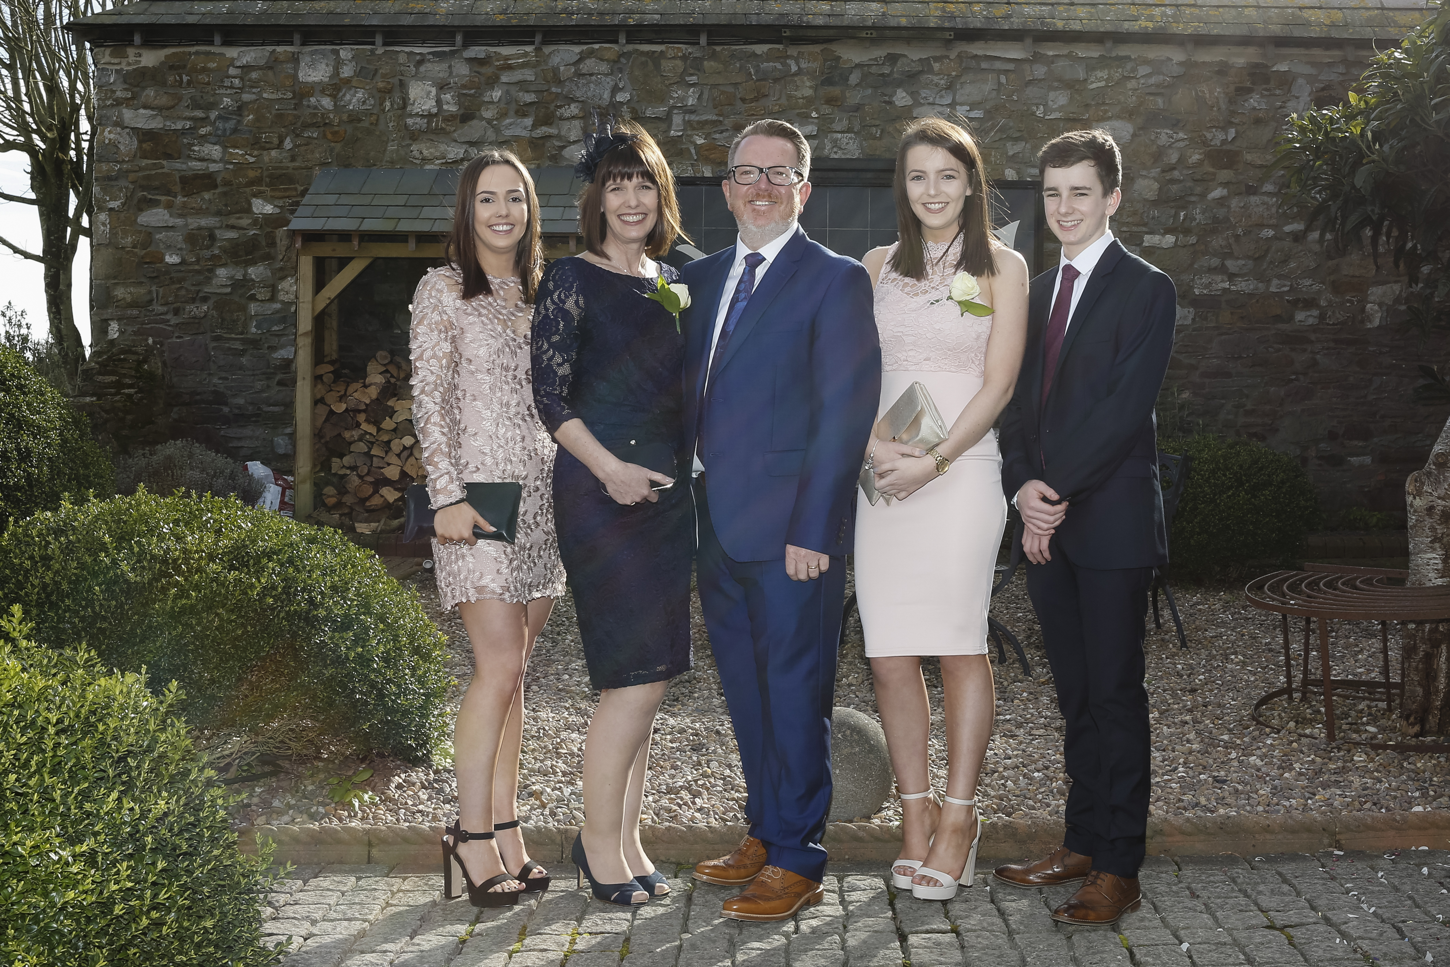
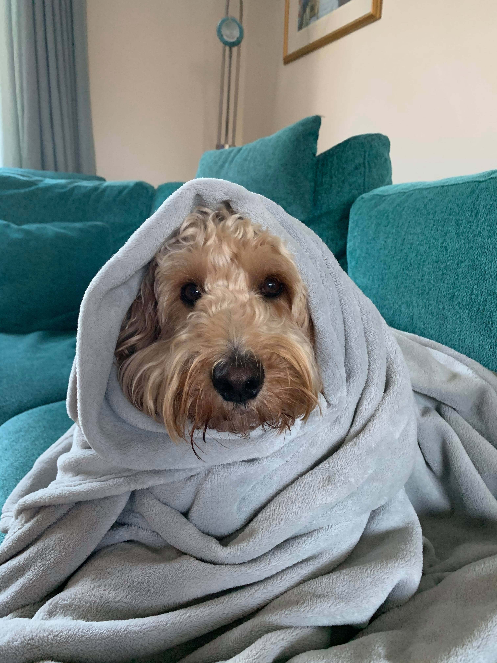
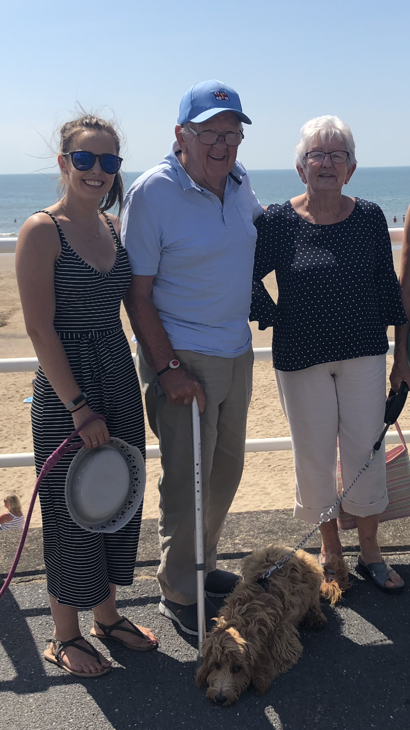

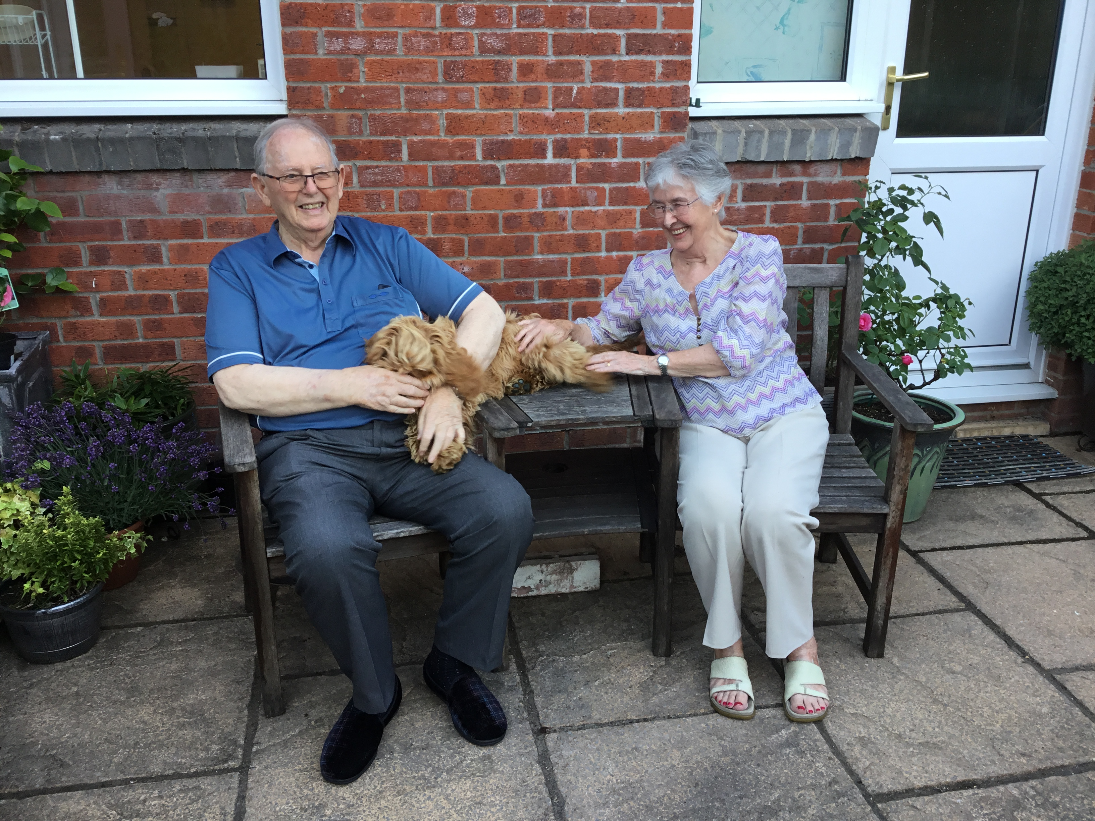

My Personal Thoughts
These are the things I am looking forward to

Meeting the new children
Being in school more often
Teaching new and exciting topics

These are the things I don’t like or will worry about

I worry that Reception class won’t be as interactive however I will try my best to make it as fun as possible.

My Personal Interests

Things I like to do | - I like swimming, I was a lifeguard before teaching.  - I like to play board games such as frustration and monopoly.  - I like to see my friends  - I like to visit my family who live in Wales
Things that I am good at | - I am good at swimming  - I am good at cooking  - I am good at making friends.
Parents, please tell us anything else that would help us to get to know you and your child better, e.g.

- What does your child enjoy doing outside of school?
- Is your child used to being with other people?
- Do they have any special friends already?

This is the first step in building a relationship with you and your child. Please continue to provide us with regular information about your child’s activities and experiences at home by talking to us and through our WOW cards. Thank you for your help.

