How To Make A Paper Lifeboat Step By Step

- Start from a rectangle. Fold in half.
Step 1
- Fold in half again and unfold.
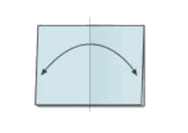Step 2
- Fold to the center.
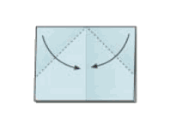Step 3
- Fold the overlapping strip upwards.
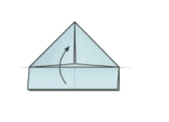Step 4
- Fold corners backwards. Turn over.
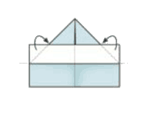Step 5
- Fold strip upwards.
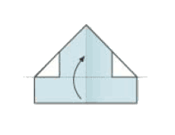Step 6
- Open.
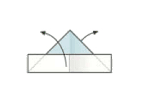Step 7
- Fold triangle upwards. Repeat behind.
Step 8
- Open (like in the steps 7 and 8).
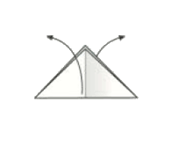Step 9
- Take upper corners and stretch out.
Step 10
- Your boat is finished.
Step 11

