How to grow a rainbow
You will need:
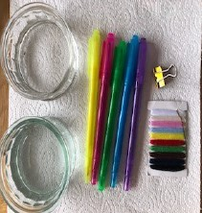
*kitchen roll *paper clip/bull dog clip * 2 bowls of water
*felt tip pens *thread

Instructions:
1.Cut the kitchen roll into the shape of a rainbow.
2. Attach the clip to the top of the rainbow and attach thread to this (optional but it means you can hold it up).
3.Colour rainbow with felt tip pens from the bottom up about 2-3cm.
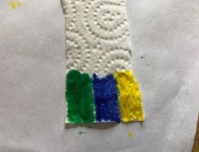

4.Hold the rainbow, the end slightly in each bowl of water and watch the colours travel up your rainbow.
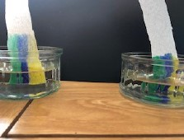
The Science bit
The ink from the coloured pens travels up the paper towel because of capillary action. Capillary action is the ability of a liquid to flow upwards against gravity (the force that pulls towards the centre of the Earth). This is the same thing that helps water travel from the roots to the leaves in trees. The kitchen paper is made up of fibres (called Cellulose) which form lots of little holes. Water likes to stick to other things (adhesion) and the rest of the water also travels through because it likes to stick together (cohesion). As it goes, it sticks to the colour and takes that too. Eventually, this process will stop because the water will be overcome by the gravitational forces.

