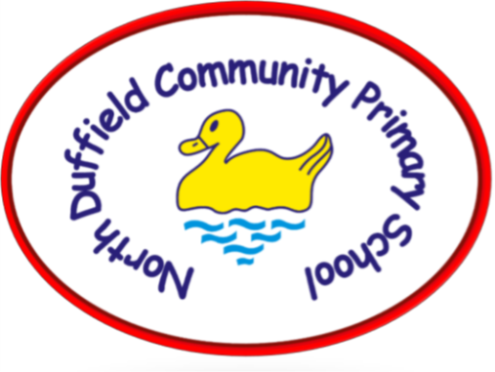

Behaviour policy

North Duffield CP School

This policy was adopted from NYES HR template dated: |  |  | November 2025
This policy was adopted by the school on: |  |  | November 2025
Estimated next review date: |  |  | November 2026
Version Control
Version | Date | Notes or amendments |  | Approval
Version 1 | 01/11/2025 |  |  | Chair of Governors

BEHAVIOUR POLICY
RATIONALE

At North Duffield Community Primary School, we recognise that good behaviour is a fundamental element for creating an environment conducive to effective teaching and learning. We believe that fostering positive behaviour involves a combination of meaningful praise and rewards, establishing strong positive relationships between staff and students, and providing engaging and impactful teaching and learning experiences. To ensure its effectiveness, we are committed to consistently implementing appropriate consequences when students have difficulties to meet the behaviour expectations of our school.

To develop our behaviour policy, we have actively sought input from students and staff, ensuring a collaborative approach. Our aim at North Duffield Community Primary School is to nurture confident and reflective students, promoting their self- esteem and cultivating a positive ethos that fosters an optimal learning environment. We strive to create an atmosphere where each individual student feels valued, respected, and empowered to thrive. It is our collective responsibility as students, parents, governors, and staff to model, reinforce, and emphasise the school's expectations of good behaviour. By working together, we can create a supportive community that encourages positive conduct and enables every student to reach their full potential.
AIMS

This policy aims to uphold the behaviour principles agreed by the staff and:

- Provide a consistent approach to behaviour management in our school.
- Define what we consider to be unacceptable behaviour, including bullying.
- Outline how pupils are expected to behave.
- Summarise the roles and responsibilities of different people in the school community with regards to behaviour management.
- Outline our system of restorative practice to support behaviour.
PROCEDURES

Purpose

- Promote Accountability and Responsibility: to foster a sense of accountability and responsibility among students. By emphasising the impact of their actions on others and providing opportunities for reflection and repair, these practices encourage students to take ownership of their behaviour and its consequences.

- Cultivate Positive Relationships: Restorative practices prioritise the building and nurturing of positive relationships within the school community. By focusing on dialogue, understanding, and empathy, these practices help repair harm caused by negative behaviour and create a supportive environment where students feel valued,
respected, and connected.

- Develop Conflict Resolution Skills: equipping students with effective conflict resolution skills. Instead of resorting to punitive measures, these practices encourage students to engage in dialogue, active listening, and problem-solving techniques to address conflicts and repair relationships.

- Enhance Learning and Well-being: The purpose of restorative practices and behaviour policies is to create a conducive learning environment where all students can thrive academically, emotionally, and socially.

Choice

At North Duffield Community Primary School, we foster a culture of personal responsibility and empower our students to effectively manage and comprehend their actions. We place great emphasis on cultivating empathy, encouraging our students to consider the perspectives of others and the broader global community. Through numerous collaborative opportunities, we aim to promote tolerance, acceptance of diverse opinions, and a strong sense of belonging within
our school community.

We firmly believe in maintaining a safe and supportive environment where no student is subjected to humiliation or shame. Instead, we strive to guide students towards making positive choices and provide them with opportunities for reflection and restitution when they fall short of those ideals. We believe in the power of learning from mistakes and working towards personal growth and improvement.

Philosophy

At North Duffield Community Primary School, we hold high standards for our students and encourage them to strive for excellence. It is the shared responsibility of staff and students to maintain our school expectations. Through proactive restorative practice, we build close class communities where all students feel valued and have a sense of belonging.
We prioritise positive language and behaviour, fostering meaningful relationships. When unwanted behaviours arise, we use restorative approaches to teach students the impact of their actions. By embracing this approach, we empower students to make responsible choices. Students at North Duffield Community Primary School are accountable for their behaviour and accept challenges and logical consequences.

For occasions when unwanted behaviours arise, we use restorative approaches as outlined in this policy, to help pupils understand the impact of their actions and behaviour. This is done through a structured restorative conversation in which we guide and teach the children how to make things right. We believe that by using this restorative approach we are giving pupils the skills to independently make better, more responsible, and more informed choices
in the future.

Expectations

Staff are expected to:
- Clearly communicate expectations and boundaries to students, ensuring they understand behavioural and academic standards.
- Nurture a trusting environment where pupils feel safe to tell an adult when any behaviours worry them.
- Promote respect and positive behaviour among students, fostering a culture of inclusivity.
- To use positive language when moving pupil’s discs in non threatening, private conversations where possible.
- Encourage self-reflection and accountability when students make negative choices, guiding them toward positive alternatives.
- Foster self-motivation and independence by providing opportunities for students to take ownership of their learning.
- Cultivate self-esteem and self-respect in students by recognising their strengths and achievements.
- Celebrate students' efforts and accomplishments to motivate and inspire them.
- Maintain an organised and engaging learning environment tailored to individual student needs.
- Respect students' perspectives and create a safe space for open dialogue.
- Lead by example, demonstrating high standards of presentation, respect, and learning behaviours.
- Collaborate with relevant staff members to support and guide each student's progress.
- By implementing these strategies, you can create a consistent and supportive learning environment aligned with the
principles of high-performance education.

Children are expected to:
- Demonstrate respect towards staff, peers, and the learning environment at North Duffield Community Primary School.
- Uphold the positive reputation of North Duffield Community Primary School in the community, both within and outside of school premises.
- Comply with the anti-bullying procedures and promptly report any instances of bullying to a staff member.
- Receive fair and equitable treatment and actively contribute to establishing classroom rules that align with the behaviour policy.
- Benefit from consistent and encouraging support from staff members to foster positive behaviour.
- Understand the behaviours that contribute to success at North Duffield Community Primary School.
- Embody the METACOGNITION values (Perseverance, Independence, Reciprocity and reflectiveness) in all aspects of academic, personal, and social life at North Duffield Community Primary School.

Rewards

At North Duffield Community Primary School, we aim to promote a positive learning environment in which all children are able to succeed through positive behaviour support systems. Our reward system is based upon rewarding effort over achievement. We aim to encourage the children to develop intrinsic motivation and pride in their work through our school values. To facilitate this, children can receive recognition of their positive behaviour and attitude through House Points, team rewards and individual praise rewards, which can be given according to one of our METACOGNITION values.

P- Perseverance
R- Reciprocity
R-Responsibility
I- Independence

Appendix 2 outlines the rewards that children may receive for house points and following our METACOGITION values.

Restorative Practice

At North Duffield Community Primary School we use restorative practice to support children’s behaviour. The escalation path in appendix 3 should be used when dealing with challenging behaviour and outlines the consequences. The behaviour matrix in appendix 4 gives examples of types of behaviour at each level and how they should be supported. The matrix is not an exhaustive list but indicative of the types of behaviours and the subsequent response and/or consequence.
In all instances, staff should be using restorative practice to support the behaviour. Restorative approaches are based on four key features:
- RESPECT: for everyone; by listening to other opinions and learning to value them
- RESPONSIBILITY: taking responsibility for your own actions
- REPAIR: developing the skills so that they have the necessary skills to identify solutions that repair harm and ensure behaviours are not repeated.
- RE-INTEGRATION: working through a structured, supportive process that aims to solve the Problem
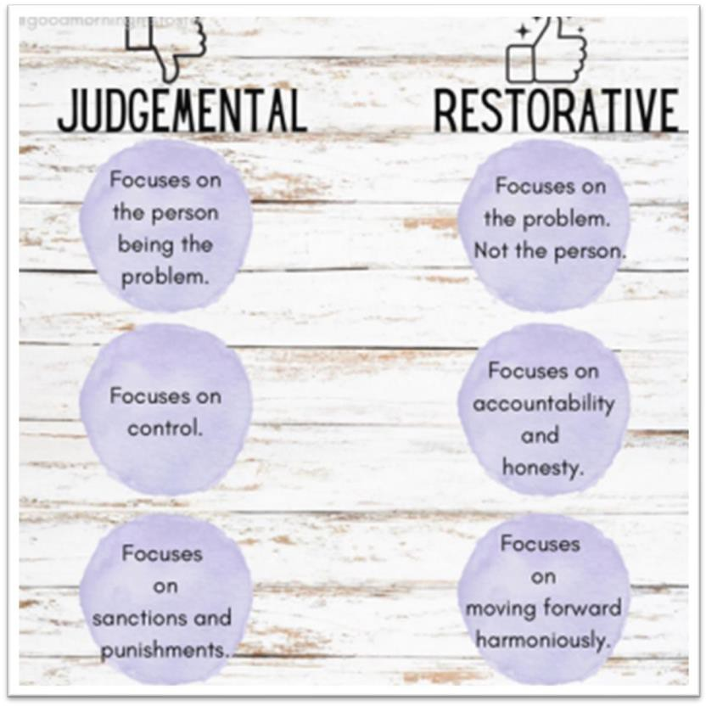

Restorative conversations can only take place when a child is regulated. In order to do this, they may require time. Staff must use their own judgement for this.

Restorative conversations should follow a clear, systematic structure. This approach enables the child to feel safe and supported. Try to have this conversation in a private place.

Children will receive a reflection sheet (appendix 5) and we will go through it with them to reflect on their behaviour, the situation and find a positive outcome using the reflection sheet as a prompt to structure the conversation.

Restorative Practice in EYFS

All classes will have a 'Calming Corner' in the classroom. In EYFS there will be puppets to reflect different feelings. The children will select a puppet with that colour to match how they are feeling. They will bring it to an adult, who will help them regulate their behaviour by using the 'what happened' restorative conversation.

They will be guided to the ‘calming corner’ area where they will be supported to regulate their own emotions: it may be drawing a picture of what has happened, cuddling a soft toy, playing with a fidget toy, or reading one of our books
about emotions. Throughout the year, the aim will be to make it more independent, so they go to the calming corner and choose their own way of regulating their emotions with less support.

Restorative Practice in Year 1 to Year 6

All classes will have a ‘Zones of Regulation’ board (appendix 8) and a ‘calming corner’ in the classroom. Children will have their own disc to place in the zone they are feeling on the board at points during the day, such as first thing in the morning and before/after breaks. Teachers should quietly and sensitively check in with pupils who are not in the green zone to see if any support is required or if strategies in the ‘calming corner’ will help. If appropriate they will be given the opportunity to regulate in the ‘calming corner’ for a minimum of 5 minutes (mindfulness, breathing, sensory tool). It may be necessary for an adult to speak to the pupil using the “What Happened” reflection sheet (appendix 5) to structure the conversation if a restorative approach has not already been used to resolve a situation, should that be the case. For identified pupils a specific approach depending on the child or/and situation may be necessary. This will be discussed with all staff.

This will give the child a chance to reflect on their behaviour without fear of judgement and they will feel supported.
From there, an appropriate next step will be decided between the teacher and the child; sometimes, the child will need some reflection time before making a decision about the next step.

Consequences

When possible, use logical consequences:
  - You broke something – How are you going to fix it?
  - You didn't do your work – When are you going to complete it?.
  - You misused equipment – I don’t think you are responsible enough to use it anymore. (or stop for a fixed period of time.)
  - You made a mess – You are going to need to clean this up? How are you going to do that?

There will be times this is not possible. In these instances, follow the behaviour escalation path in appendix 3.

Children should not be sent out of class for any behaviour incident. When needed, the children can step out of class to regulate their feelings or give teachers time to regulate their own feelings, but they should be followed outside within two minutes to have a restorative discussion.

When children exhibit undesirable behaviour (please refer to the behaviour matrix for list of behaviours appendix 4) to identify how the behaviour should be treated.

Level 1 behaviour should be dealt with the member of staff who encounters it.

Level 2 behaviour should be reported to the class teacher who will talk to the child and deal with it accordingly. After discussion with the SLT incident may be added to CPOMs.

Level 3 behaviour should be reported to the KS Lead. At this stage parents will be informed, and the incident needs to be recorded. The incident will be recorded on the school’s management information system (CPOMS). The SLT will decide what the consequence will be.

Level 4 behaviour should be reported straight to Headteacher. At this stage parents will be informed and where necessary, they will be invited to a meeting. The incident will be recorded on the school’s management information system (CPOMS) and SLT will decide on the appropriate consequences.

Where children are consistently demonstrating level 1 and 2 behaviours (3 or more instances) this should also be recorded on CPOMS and will be followed up by SLT.

Harmful Sexual Behaviours

Our school has a zero-tolerance approach to any harmful sexual behaviour involving children and acknowledges that it could be occurring at schools and in our school communities. The school is proactive in their approach to assessing prevalence, responding to incidents and challenging and changing behaviour.

Schools have a statutory duty to safeguarding the children in their setting. We work together to foster an environment that creates healthy relationships for children.

Our approach encourages healthy relationships and works to prevent harmful sexual behaviour. We provide high quality education within the curriculum to reduce the likelihood of the situations occurring.

We recognise that harmful sexual behaviour is harmful to both the child/children affected by the behaviours and the child/children who displayed the behaviour and provide ongoing support for all involved.

Our approach is to treat everything as a safeguarding incident in the first instance - we distinguish between behaviours that are exploratory and part of healthy age and ability appropriate development and those that may be harmful.

As a school, we provide regular opportunities for school staff to understand what harmful sexual behaviours might look like and what they should do in the event of a report. We do this by providing training and regular updates where possible and using the NSPCC Traffic Light tool:

Responding to children who display sexualised behaviour (nspcc.org.uk)

We also use the RSHE/PSHCE curriculum to help educate students about these issues as well as regularly reminding and promoting the reporting routes within our schools to ensure they know what to do should an incident occur.

In addition to the above, further information is available from the North Yorkshire Safeguarding Children Partnership:

https://safeguardingchildren.co.uk/beaware-professionals/hsb/

Neurodiversity

Effectively managing the behaviour of neurodiverse pupils requires a comprehensive approach that fosters understanding and collaboration. Teachers will need to make adaptations to support the behaviour of different children. For children with EHCP’s or an identified neurodiversity behaviour a discussion should be held with the inclusion team to gain insights into each student's unique needs and challenges and which strategies would best support this. Drawing from these conversations, tailored strategies are then developed, aligning with the principles of restorative practice. These strategies encompass a range of approaches, including visual supports, sensory accommodations, and individualised behaviour plans that consider triggers and preferred coping mechanisms. By embracing restorative principles, such as active listening, empathy, and promoting positive relationships, educators can address behavioural issues in a holistic manner. Regular reviews and adjustments of strategies, in consultation with the inclusion team should be held to ensure a supportive and inclusive environment where neurodiverse pupils can thrive academically and socially.

All staff will be made aware of any child where reasonable adjustments or separate plans have been identified through Pyramid of Needs staff meetings (fortnightly staff meetings or sooner if it is urgent).

The Zones of Regulation at North Duffield Primary School
Please see Appendix 7 for information

APPENDICES

Appendix 1 - Meeting the needs of children

Ways in which the children are supported at North Duffield
- PSHE taught throughout Primary
- Mindfulness breaks
- Calm areas in each classroom
- Wellbeing support (Pastoral Support Team)
- A comfortable neutral environment

Appendix 2 – Rewards

Reward system House Points-

House Points Collaboration
House Points will be collated through each house (Indie, Try & Try Again, Mirror and Percy). Each team has a jar to collect house points, when a level is reached the house earns a reward.

Hierarchy of rewards
- 20 Minutes of OPAL Play
- Non Uniform Day
- Film Afternoon
- Den Building and forest School
- Water/ pool afternoon.

Praise Certificates
Each member of staff will award a praise certificate and 5 house points for any student displaying outstanding achievement or behaviours in line with our METACOGITION values.
Appendix 3
Behaviour Escalation
Steps
How we will support the behaviour of each child to keep a safe and calm environment for learning. In all cases we will use restorative practice to support the discussion.
Staff who encounter behaviour concern will address the behaviour following the policy.

1

Headteacher will address the behaviour concern. Parents will have a meeting if necessary.
4
SLT/ PSO will have a discussion with the child. Parents will be informed.
3

Class teacher will be informed. Contact will be made with parents.

2
Level of Behaviour

Appendix 4- Levels
Level 1 | Possible consequence
- Not completing sufficient work in class  - Throwing items in the classroom  - Failure to complete work to an appropriate level  - Littering  - Not paying attention  - Talking at inappropriate times  - Running in the corridors  - Not lining up quietly  - Deliberately failing to follow instructions.  - Unkind words used towards another student/staff member.  - Teasing/taunting classmates | - Non-verbal cue  - Verbal reminder of expectations  - Warning  - Restorative conversation  - Logical consequence  - Disc moved on to expectation to support restorative approach
Level 2
- Repetition of any low-level behaviour  - Disrespecting a member of the community  - Repeated verbal or physical abuse towards a member of the community (including via the internet) | - Verbal reminder of expectations  - Warning- incident placed on CPOMs  - Restorative conversation  - Logical consequence  - Disc moved on to expectation to support restorative approach  - Staff discussion and use of Pyramid of Need.  - Contact will be made with parents
Level 3
- Repetitions of any mid-level behaviour  - Fighting  - Deliberately damaging property or the property of another student | - Warning- incident placed on CPOMs  - Staff discussion and use of Pyramid of Need.  - Restorative conversation  - Sent to SLT/PSO for restorative conversation.  - Damage to property may require parents to pay for the damage.  - Fighting may require a child being removed from the environment (to safeguard the other children)- Breaktime restorative time (time to reflect and regulate) with the Pastoral team in their room- if it’s inside break staff should find an alternative space  - Fighting and deliberate damage on more than one occasion may result in an internal exclusion with the Headteacher
Level 4
- Racist behaviour – Derogatory or discriminatory language and actions towards anyone  - Serious or repeated intimidation  - Physically assaulting another student or staff member  - Major theft (money, valuable item)  - Bullying- See Anti-bullying policy | - Sent to Headteacher for restorative conversation.  - Potential breaktime detention  - Potential internal exclusion inside or outside on the playground.  - Potential external exclusion  - incident placed on CPOMs

Appendix 5

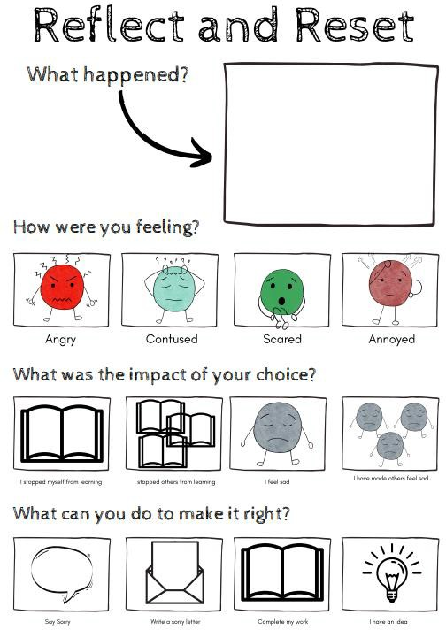

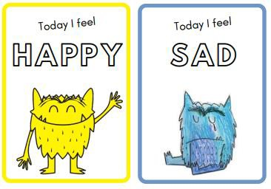
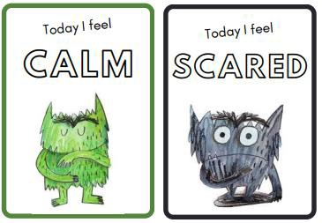
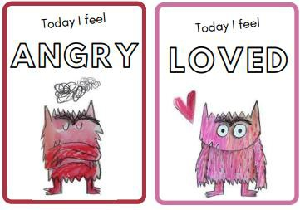
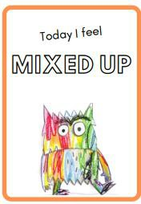

Appendix 6

BEHAVIOUR LANGAUGE EXAMPLES
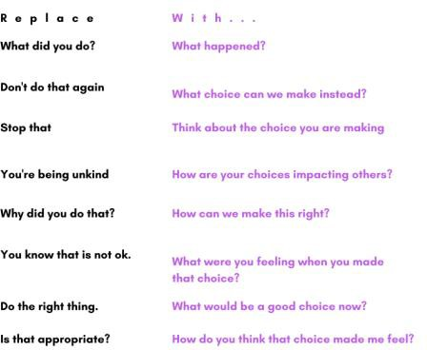

Appendix 7
Zones of Regulation Boards
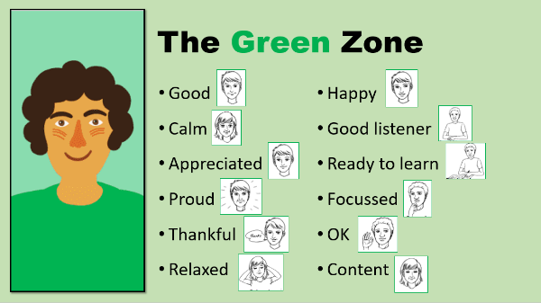
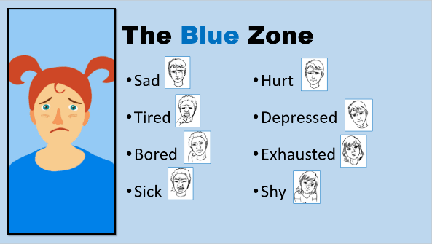

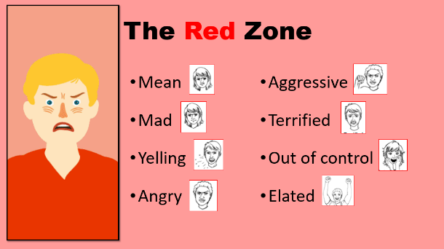
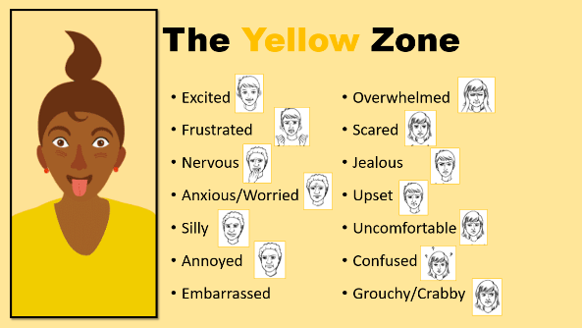

The Zones of Regulation at North Duffield Primary School

The Zones of Regulation is a framework to help children recognise their feelings and develop tools and strategies to regulate them. It is a very visual, scaffolded approach that builds awareness of feelings and the internal, physical response this produces. The approach is systematic, teaching regulation through categorising the different ways we feel into four concrete, coloured zones (see above). Recognising and labelling emotions in each zone is the first stage in this process. Asking our children how they’re feeling at different points across the day is a great way to begin reflecting on and labelling their own emotional state. Ultimately this can support increased control over their own feelings and encourage their problem-solving abilities.
The main purpose of the zones is to expose children to a variety of tools and strategies within each zone by substituting impulsive reactions with regulating activities that supports their mental well-being. This is something that needs to be supported with younger children in particular. They find it hard to manage ‘big feelings’. When we support in this way, sharing our understanding and acknowledging how they are feeling, it is called co-regulation. Ultimately, we want our children to be able to self-regulate but co-regulation may be needed for some time, and especially when in crisis.
One thing we must remember as adults is that in order to offer support, we must provide a calm presence ourselves. We need to be regulated to ensure that we are able to listen to our children and validate and empathise with what they are feeling. We may want to give examples of our own experiences but we must be mindful that the child is the focus. Once the child understands we are trying to support them we can then suggest a calming activity and space. This supports de-escalation of intense feelings to move to a less intense zone e.g. from Red Zone to Yellow Zone. Returning to a conversation later may be appropriate once the child is regulated. It is also important to remember that there is no ‘right’ zone to be in. Green Zone is not a goal. We need to support our children in whichever zone they are feeling. While Green Zone is the zone we all prefer to be in, it is ok to be in any zone; all zones reflect normal feelings and emotions. The focus needs to be on what strategies can be used to support the zone they are in. We want our children to build a tool box of strategies and to be confident in talking about how they are feeling.

